APPROVED

by decision of the Board of Directors

Kazakhstan Іndustry and export

Center «QazIndustry» JSC from «24 » September 2024

(protocol No. 08/24)

PRE-APPROVED

by decision of the Board Kazakhstan

Іndustry and exports

Center «QazIndustry» JSC

dated July 18, 2024.

(protocol No. 20)



**Activity report**

**Kazakhstan Industry and Export Center «QazIndustry» JSC for 2023**

Astana, 2024

**Content**

I. About the Company 5

1.1. Name of the Company, legal address and location of the Company 4

1.2. Information on state registration, functions of the Company in accordance with the current legislation of the Republic of Kazakhstan and the Charter of the Company 4

1.3. Structure of the authorized capital, including information on the number and par value of issued shares, description of rights granted by the shares, number and par value of authorized but unplaced shares, Sole shareholder, number of common shares assigned to it 7

1.4. On the Company's mission, vision and development strategy 8

1.5. On the results of implementation of the Company's Development Strategy 10

1.6. Organizational structure 13

II. Results of the Company's activities for 2023 by strategic directions 15

2.1. Expert-analytical activity as a "think tank" for the development of industry and related sectors in Kazakhstan 15

**2.1.1. Information and analytical support of industrial and innovative development** 15

**2.1.2. Participation in the formation of the National report on the state of industry of the RK** 22

**2.2. Provision of systemic and direct state incentives in manufacturing industry** 25

**2.2.1. Participation in the implementation of systemic measures to support the development of the manufacturing industry** 25

**2.2.1.1. Improving the competitiveness of processed goods** 25

**2.2.1.2. Development of territorial clusters** 26

**2.2.1.3. Development of the domestic market for processed goods** 27

**2.2.1.4. Supporting industrial development within the framework of integration processes of Kazakhstan** 31

2.2.2. Provision of direct state incentives to manufacturing enterprises 32

**2.2.2.1.****Reimbursement of labor productivity improvement costs** 33

**2.2.2.2. Reimbursement of expenses for promotion of goods, works and services in the domestic market** 35

**2.2.2.3. Provision of state incentives for industry in the development of territorial clusters** 36

**2.2.2.4. Provision of industrial grants** 37

2.3. Promoting the development of industries and spheres of economy related to the manufacturing industry 38

**2.4. Coordination of development of special economic and industrial zones of the Republic of Kazakhstan** 38

**2.4.1. Coordination functions and interaction with authorized state bodies** 38

**2.4.2. Improving the quality of management in special economic and industrial zones** 39

**2.4.3. Promotion of special economic and industrial zones of the Republic of Kazakhstan** 40

**2.5. Incentivize industrial enterprises to introduce digital technologies into production processes** 41

**2.5.1 Expertise in industry transformation and implementation of Industry 4.0 area** 41

**2.6. Institutional development of QazIndustry** 45

**2.6.1. Improvement of corporate governance** 45

**2.6.2. Development of competencies** 46

**2.6.3. Commercialization of certain types of services** 47

**2.6.4. Improving operational efficiency** 47

**2.6.5. Human capital development** 48

**2.6.6. Increased transparency in QazIndustry activities** 49

III. Financial and operating results 50

3.1. On fulfillment of operational and financial performance indicators 50

3.2. On key material corporate events and achievements 51

3.3. On major transactions and liabilities with related parties 52

3.4. On any financial support, including guarantees received/received from the state and any obligations to the state and society assumed by the Company 53

IV. Structure of Assets 53

V. Objectives and plans for future periods 53

VI. Main risk factors and risk management system 54

VII. Corporate governance 56

7.1. Corporate governance structure, composition of the board of directors, report on the activities of the board of directors and its committees 56

7.2. Information on compliance of corporate governance practices with the principles of the Company's Corporate Governance Code, and in case of non-compliance - explanations on the reasons for non-compliance with each of the principles 59

7.3. Composition of the Management Board of the Company, report on the activities of the Management Board of the Company 65

7.4. Remuneration policy for officials 66

VIII. On sustainable development 67

[Appendix No. 1 Report on fulfillment (monitoring) of indicators of the Company's Development Strategy for 2023 70](#Appendix_No._2_Report_on_fulfillment_(mo)

[Appendix No. 2 Report on fulfillment (monitoring) of indicators of the Company's Development Plan for 2023 76](#Appendix_No._2_Report_on_fulfillment_(mo)

**[Appendix No. 3 Auditor's Report and Basic Financial Statements Forms for 2023](#Appendix_No._2_Report_on_fulfillment_(mo)**

**[………………………………………………………………………………….. 80](#Appendix_No._2_Report_on_fulfillment_(mo)**

**ADVERTISEMENT**

**Chairman of the Board of Directors of the Company**

***Dear Colleagues!***

One of the priorities of the state policy is further development of industry and strengthening of industrialization.

In his Address «Economic course of fair Kazakhstan», the President of the country Kasym-Jomart Tokayev paid special attention to the industrial sector. The head of state instructed to form a «strong industrial cluster» to ensure economic self-sufficiency of Kazakhstan.

Now the country's policy is aimed at increasing the volume of competitive and export- oriented products, moving away from the raw materials model of development and ensuring sustainable growth of the manufacturing industry.

Kazakhstan Industry and Export Center «Qazindustry» makes a certain contribution to this. Thanks to the measures of state stimulation provided by the Company, many industrial enterprises have introduced digital technologies into production processes, increased their capacities, thereby improving their competitiveness.

Program documents are developed on the basis of the research conducted by Qazindustry. In 2023, QazIndustry has developed more than 70 recommendations on issues of industrial and innovative development.

QazIndustry team is facing important tasks for the development of manufacturing industry and in-country value. I am convinced that the Company will only strengthen its position in the development of industry.

I express my gratitude to the employees of QazIndustry for their high professionalism and responsibility. I am convinced that each of you makes a worthy contribution to the development of Kazakhstan's industry and the growth of competitiveness of the national economy.

**Sincerely, Chairman of the Board of Directors Kazakhstan Industry Center JSC**

**and export "QazIndustry" О. Saparbekov**

**ADVERTISEMENT**

**Chairman of the Management Board of the Company**

***Dear colleagues, clients, partners!***

Kazakhstan Industry and Export Center «QazIndustry» as a national institute for the development of industry and in-country value continues to work to promote the growth of competitiveness of manufacturing enterprises and the development of special economic and industrial zones.

The Company provides state incentives to domestic enterprises aimed at reimbursement of part of the costs of increasing labor productivity and promotion of products on the domestic market. In addition, QazIndustry provides support to enterprises for the introduction of digital technologies. The range of state support measures is expanding and improving every year.

In total for the reporting period QazIndustry reimbursed Kazakhstani enterprises for more than 844 million tenge.

To develop industrial cooperation, the Company holds annual Subcontract Exchanges. As a result of the Exchange-2023, 10 off-take contracts and 35 long-term agreements for the purchase of goods of domestic manufacturers were concluded for more than 47.5 billion tenge.

QazIndustry is working on monitoring and analyzing industrial policy, helping to identify promising areas of manufacturing industry, to promote their development. The Society continues to work on strengthening the competitiveness of the manufacturing industry and increasing in-country value.

I would like to thank every employee of QazIndustry for fruitful and effective work. I express my gratitude to our clients and partners for their support and initiatives, thanks to which the domestic industry is progressively developing.

**Respectfully, Chairman of the Board**

**Kazakhstan Center**

**JSC QazIndustry and Export B.Bekenov**

1. **About the Company**
   1. Name of the Company, legal address and location of the Company

**Full Name:**

in the state language: «QazIndustry» Қазақстандық индустрия және экспорт орталығы» акционерлік қоғамы («QazIndustry» Kazakhstan Industry and Export Ortalygy» shareholder);

in Russian: Акционерное общество «Казахстанский центр индустрии и экспорта «QazIndustry» ( «Kazakhstan Center of Industry and Export «QazIndustry» Joint Stock Company);

in English: «QazIndustry» Kazakhstan Industry and Export Center» Joint Stock Company.

**Abbreviated name:** in the state language: «QazIndustry» KIEC «QazIndustry» JSC; in Russian: KIEC «QazIndustry» JSC; in English: «KIEC «QazIndustry» JSC.

**Legal address:** Republic of Kazakhstan, 010000, Astana city, Esil district, 17, block E, Kabanbay Batyr Ave.

* 1. Information on state registration, functions of the Company in accordance with the current legislation of the Republic of Kazakhstan and the Charter of the Company

«Kazakhstan Industry and Export Center «QazIndustry» JSC *(renamed from JSC «Kazakhstan Institute of Industry Development»)* was established by the Government of the Republic of Kazakhstan on June 3, 2010 № 508 (registered in the Department of Justice of Astana on June 24, 2010 under № 37161-1901-АО).

In accordance with the resolutions of the Government of the Republic of Kazakhstan dated December 13, 2018 No. 830 «On some measures to optimize the management system of development institutions» and dated February 20, 2019 No. 75 «On amendments to some decisions of the Government of the Republic of Kazakhstan», the Company was reorganized by joining the joint-stock company «National Agency for Development of Local Content «NADLoC» and determined as a national institute in the field of industry development, technological development, local content development, and development of local content.

By the Resolutions of the Government of the Republic of Kazakhstan dated April 19,

2019 № 215 and dated July 29, 2019 № 546, JSC «Kazakhstan Institute of Industry Development» *was renamed* to JSC «Kazakhstan Center of Industry and Export» and then to **Joint Stock Company «Kazakhstan Center of Industry and Export «QazIndustry»** *(hereinafter - the* ***Company or QazIndustry***) (*certificate of state re- registration of the legal entity dated August 29, 2019).*

By the Resolution of the Government of the Republic of Kazakhstan dated November 21,

2022 № 932 «On approval of the list of national development institutes and other legal entities, fifty and more percent of voting shares (participation shares in the authorized capital) of which directly or indirectly belong to the state, authorized to implement measures of state stimulation of industry», the Company is defined as a **national development institute in the field of industry development and development of in- country value.**

In accordance with the Resolution of the Government of the Republic of Kazakhstan

dated June 3, 2010 No. 508 (amended by the Resolution of the Government of the Republic of Kazakhstan dated July 3, 2019 No. 469), the Law of the Republic of Kazakhstan

«On Special Economic and Industrial Zones», the Company performs the functions of the **Single Coordination Center for Special Economic and Industrial Zones** in the Republic of Kazakhstan.

According to the **Company's Charter** approved by the order of the Minister of Industry and Infrastructure Development of the Republic of Kazakhstan dated November 2, 2022 № 606, the Company's activities are:

* providing information, analytical and consulting services in the field of economic sector development, including the development of the manufacturing industry, industrial and innovative development of regions, digital transformation of industry and implementation of Industry 4.0;
* Providing services to the authorized agency in the area of state incentives to industry on:

elaboration of proposals on the list of priority goods; to accompany the unified map of industrialization;

providing industrial grants to recipients of state incentives for industry; selection, support, monitoring and analysis of the implementation of agreements

on competitiveness improvement;

analyzing the effectiveness of the implementation of measures of state stimulation of industry;

monitoring of counter-obligations;

to conduct an assessment of industrial development;

development of recommendations on digital transformation of industry and implementation of Industry 4.0 by the subjects of activity in the sphere of industry, as well as support in the implementation of the recommendations;

* rendering services on provision of measures of state stimulation of industry aimed at increasing labor productivity of subjects of industrial-innovative activity;
* provision of services on provision of state incentives for industry in the development of territorial clusters and support of territorial cluster development processes;
* provision of services on analytical and expert support of the activities of the interdepartmental commission on industrial policy;
* rendering services on realization of documents of the System of state planning in the Republic of Kazakhstan in the sphere of industrial-innovative activity, providing analysis of statistical information and data on realization of documents of the System of state planning in the Republic of Kazakhstan in the sphere of industrial-innovative activity, received from state bodies and subjects of entrepreneurship, as well as development of proposals and expert opinions;
* monitoring and analyzing job creation and staffing needs of manufacturing enterprises;
* formation and maintenance of a database of goods, works, services and their suppliers;
* provision of information and analytical, consulting services in the field of development and monitoring of in-country value, including expertise of in-country value;
* Providing services to the authorized agency in the area of state incentives to industry on:

provision of state incentives for industry aimed at promoting goods, works and services of subjects of industrial-innovative activity in the domestic market;

service support of subjects of industrial and innovative activity in the domestic market, including support of information systems designed for the development of in- country value and acquisition of goods, works and services used in subsoil use operations;

* is a subcontracting center.

Subcontracting refers to one of the forms of production (industrial) outsourcing used by industrial enterprises to optimize production activities;

* interaction with state authorities, participants (shareholders) of management companies, management companies of special economic and industrial zones, participants of special economic and industrial zones, persons engaged in non-core activities on the issues of registration of such participants and persons and development of infrastructure of special economic and industrial zones;
* making proposals to the authorized body on improvement of the legislation of the Republic of Kazakhstan on special economic and industrial zones;
* trust management of participation interests in the authorized capital (shares) of management companies of special economic and industrial zones owned by the state;
* maintaining a unified register of participants of special economic zones;
* issuance of a certificate certifying registration of a person as a participant of a special economic zone;
* maintaining a unified register of industrial zones;
* monitoring of fulfillment of the terms and conditions of agreements on the implementation of activities and agreements on the implementation of non-core activities in the territories of special economic and industrial zones;
* monitoring the condition of infrastructure facilities of special economic and industrial zones;
* monitoring the achievement by the management company of the special economic or industrial zone of the target indicators set out in the development strategy;
* provision of services for the development and promotion of special economic and industrial zones, including:

development and implementation of a management model, internal business processes and corporate documents in management companies of special economic and industrial zones;

elaboration of recommendations (proposals) on the development strategy of special economic and industrial zones, criteria for selection of projects for special economic zones, planning of financing of managing companies of special economic and industrial zones, development of financing plans (budgeting and consolidation) of special economic and industrial zones;

training of employees of management companies of special economic and industrial zones;

conducting market analysis and consulting managing companies of special economic and industrial zones on the development of marketing strategy of special economic and industrial zones;

conducting targeted marketing; Conducting project analysis;

ensuring promotion of domestic special economic and industrial zones in the international market;

providing information support for the activities of potential participants of special economic and industrial zones and persons engaged in non-core activities;

providing assistance in attracting potential investors to special economic and industrial zones;

* assisting in achieving the target indicators of the strategic documents of the authorized body.
  1. Structure of authorized capital, including information on the number and par value of issued shares, description of rights granted by shares, number and par value of authorized but unissued shares, Sole shareholder, number of common shares held by him/her

Amount of the Company's authorized capital: 217,971,000 tenge.

The Company placed and paid for 204,932 common shares, which were assigned the international identification number (ISIN code) KZ1C00005982:

-100,000 common shares with par value of KZT1,000;

-104,932 common shares with par value of KZT1,124.26. There are no authorized but unissued shares of the Company.

According to the Law «On Joint Stock Companies» a common share gives the shareholder the right to participate in the general meeting of shareholders with the right to vote on all issues put to vote, the right to receive dividends if the Company has net income, as well as part of the company's property upon its liquidation in accordance with the procedure established by the legislation of the Republic of Kazakhstan.

The rights of the **Sole Shareholder of the** Company are vested in the **Ministry of Industry and Construction of the Republic of Kazakhstan** (BIN 231040007978, located at the address: Republic of Kazakhstan, 010000, Astana city, Esil district, Kabanbay Batyr Avenue, building 32/1, «Transport Tower».

* 1. About the Company's mission, vision, development strategy

**Development Strategy of** Kazakhstan Industry and Export Center JSC «QazIndustry» **for 2020-2024** was approved in a new version1[1] by the Board of Directors of the Company on July 15, 2022 (hereinafter - QazIndustry Strategy). By the decision of the Board of Directors of the Company dated November 28, 2023, the QazIndustry Strategy was amended in terms of specifying target indicators *(brought in line with the indicators of the Development Plan of the Company)*.

QazIndustry's strategy defines QazIndustry's mission, vision, strategic directions and objectives for the 5-year period, as well as activities contributing to the achievement of the set strategic goals and objectives, and is focused on ensuring contribution to the achievement of strategic and program documents of the Republic of Kazakhstan in the field of industrial and innovative development of the country.

***The Company's mission*** is to contribute to the growth of competitiveness of the manufacturing industry and related sectors of Kazakhstan's economy.

***The vision of the Company*** by 2025 is to become a national Think Tank («think tank») for the development of industry and related industries in Kazakhstan, as well as an effective operator in providing state incentives for manufacturing enterprises.

**QazIndustry's strategic directions:**

* 1. Expert-analytical activity as a «think tank» for the development of industry and related sectors of Kazakhstan.
  2. Provision of systemic and direct state incentives in the manufacturing industry.
  3. Promoting the development of industries and spheres of the economy related to manufacturing.
  4. Coordination of development of special economic and industrial zones of the Republic of Kazakhstan
  5. Incentivizing industrial enterprises to implement digital technologies in production processes.
  6. Institutional development QazIndustry.

Within the framework of the above strategic directions, the Company **has *15***

***tasks****:*

1. **Information and analytical support of industrial-innovative**

**development**, including regular monitoring and analysis of the results of the implementation of documents of the RK State Planning System on industrial- innovative development, analysis of the development of manufacturing industries, support of the Unified Map of Industrialization projects, development of proposals to improve industrial policy and the system of state stimulation of industrial-innovative activity.

1. **Participation in the formation of the National report on the state of industry of the Republic of Kazakhstan**, including assessment of industrial development and assessment of the effectiveness of the implementation of measures of state stimulation of industry, proposals for the formation, implementation and improvement of further industrial policy.
2. **Participation in the implementation of systemic measures to support the development of the manufacturing industry**, including measures to improve the competitiveness of processed goods, the development of territorial clusters, the development of the domestic market for processed goods, and support for the development of industry within the framework of Kazakhstan's integration processes.
3. **Provision of direct measures of state incentives for manufacturing enterprises,** including reimbursement of costs for increasing labor productivity, promotion of processed goods, works and services in the domestic market, provision of state incentives aimed at supporting territorial clusters, as well as industrial grants.
4. **Information-analytical and expert support for the development of individual industries and spheres of the economy,** including analytical research of domestic and foreign markets in the field of transportation with the preparation of expert opinions and proposals for the balanced development of transport infrastructure with the elaboration of proposals and recommendations.
5. **Coordination functions and interaction with authorized state bodies on the development and promotion of FEZs and IZs,** including maintaining a unified register of FEZ and IZ participants and issuing registration certificates to FEZ participants, participation in coordinating the completion of infrastructure construction, conducting audits and analysis of the efficiency of existing FEZs, and developing proposals to improve their efficiency.
6. **Improving the quality of management in FEZs and IZs,** including good corporate governance through participation in the Board of Directors as independent directors, making recommendations on the development of FEZ and IZ development strategy, criteria for selecting projects for FEZs, developing and establishing business processes and internal procedures, creating mechanisms for solving problematic issues of activity and development, protecting interests, training employees, engaging consultants.
7. **Promotion of special economic and industrial zones** (hereinafter

- SEZs and IZs) of the **Republic of Kazakhstan** to attract investors to the sites of existing SEZs and IZs.

1. **Expert activities in the field of digital transformation of industry and implementation of Industry 4.0,** including development and support of implementation of digital strategies/recommendations on digital transformation of industry and implementation of Industry 4.0 by industrial enterprises, formation and development of expert knowledge base in the field of Industry 4.0 for manufacturing industries, creation of conditions for replication of model digital factories, stimulation of measures in the field of digital transformation.
2. **Improve**

**ment of QazIndustry's corporate governance** by means of annual formation and implementation of the Company's corporate development improvement plans.

1. **Develop**

**ment of QazIndustry competencies** by building up industry competencies**,** development of research instrumentation, continuous training of employees, cooperation with specialized organizations and expert community, etc.

1. **Commer**

**cialization of certain types of services** (information-analytical and consulting, marketing research).

1. **Increasin g operational efficiency,** including digital transformation of the Company (automation of business processes, integration of digital systems), improvement and re-engineering of business processes.
2. **Develop ment of human capital** by implementing **human resources** policy, improving working conditions and safety, and maintaining a favorable microclimate.
3. **Increasing transparency in QazIndustry's activities** through timely and complete disclosure of information, coverage of activities in the media, on the Company's website, in social networks, interaction with business, government agencies, development institutions, creation of a pool of public experts of the Company, response to incoming signals.

For successful implementation of strategic goals and objectives, the Company is interested in active support from the Sole Shareholder and the Board of Directors of the Company, close cooperation with authorized state bodies and development institutions, large-scale involvement of business in the processes of industrial and innovative development.

* 1. On the results of implementation of the Company's Development Strategy

In 2023, **29** out of 33 **targets (87.9%) of the** QazIndustry Development Strategy have been **achieved or exceeded**.

Within the framework of the strategic direction «**Expert-analytical activity as a «think tank» for the development of industry and related sectors»:**

-provided **16** *services in the field of industry development* (plan - **15**), including

**1** - on development of subsoil use;

-based on the results of the conducted research **150** *proposals and recommendations on the issues of further industrial-innovative development* (plan - **90**) were sent to the authorized state bodies (Ministry of Industry and Construction of the Republic of Kazakhstan, hereinafter - MPS, Committee of Industry of MPS RK and others);

* Reporting information on the results of *industrial development assessment* and analysis of the effectiveness of the implementation of state incentives for industry was provided (plan - **1**);

In the implementation of the strategic direction «**Provision of systemic and direct state stimulus measures in the manufacturing industry»:**

* with the assistance of the Company, subsoil user companies concluded **35** *long- term guaranteed contracts* with domestic producers for a total amount of 47.5 billion tenge (plan - **35**), as well as **10** *off-take contracts for the* purchase of goods totaling over KZT 6 bln (plan - **10**);
* **40** domestic companies received the status of accredited supplier from such major customers as Kazakhmys, ERG, Kazzinc, Polymetal Eurasia and Samruk- Kazyna (plan - **40**);
* as a result of *diagnostics of the current state of cluster initiatives in the* regions of Kazakhstan in the sphere of manufacturing industry, **29** cluster formations are recommended for further work and inclusion in the register of territorial clusters (plan - **5**);

the *complex analysis of industrial concentration* (specialization) of **20** *regions of* Kazakhstan, taking into account quantitative and qualitative analysis of economic industrial concentration, functioning value chains, large enterprises in the regions, as well as the state of cooperation ties between enterprises (plan - **20**);

* **4** *barriers and restrictions* preventing the free movement of domestic industrial products within the EAEU territory were identified (plan - **3**);
* Within the framework of support of the *Unified Industrialization Map projects,*

analytical information on **391** projects was generated (plan - **330**);

* **10** *investment passports* on priority goods were developed (plan - **10**);
* maintenance of **2** *information systems* – «Register of goods, works and services used in subsoil use operations and their producers» and Internet Portal «Kazakhstan Content» (plan - **2**);
* **48** projects of entrepreneurs, received state incentives to promote processed goods, works and services on the domestic market (plan - **42**);
* **53** enterprises *received state incentives* by means of reimbursement of expenses on labor productivity increase for the total amount of 810.9 million tenge (plan - **51**);
* **47** enterprises that received state incentives to increase labor productivity

*fulfilled their counter obligations* (plan - **46**).

As a result of the Society's **coordination of BMS and EZ development:**

*-growth of production volume of goods and services* (*works) in FEZ territories* (excluding FEZ «NINT», «Khimpark Taraz», «Khorgos-Eastern Gate») amounted to **113.5%** to the previous year (plan - 113.5%);

* **87** *investors* were registered *as FEZ participants* (excluding construction of administrative and residential complexes) (plan - **70**).

As a result of the work carried out to **stimulate industrial enterprises to implement digital technologies in production processes:**

* *the share of large and medium-sized enterprises in the manufacturing industry* using digital technologies amounted to **16.4%** (the plan was **15%**);
* **445** specialists, including 311 top managers of industrial enterprises in all regions of the country were *trained on the topics of Industry 4.0 (plan - 50 people) Industry 4.0* (plan - **50** people);
* *The Industry 4.0 knowledge base* has been enriched with publications on **3** branches of manufacturing industry *(rubber and plastic products, non-metallic mineral products, furniture industry)* (plan - **2**)*;*

-developed **21** recommendations on *digital transformation of industry and implementation of Industry 4.0 by the* subjects of activities in the field of industry, as well as support during implementation (plan - **20**) .

As part of the **institutional development of QazIndustry**:

* all measures (**100%**) of the *Company's Corporate Development Improvement Plan* for 2023 were implemented (plan - **100%)**;
* **506** materials (articles, interviews, stories and TV programs) on industrial and innovative development of Kazakhstan and the Company's activities (indicators of Kazakhstan's industry, integration processes, world experience of industrial policy, development of FEZs/IZs and others) were *published in mass media and on the* Company's *website* (plan - **90**);
* *the degree of customer satisfaction with the quality of operator services*

provided by the Company amounted to **81%** (plan - 70%);

* the Company's *staff turnover* amounted to **8.16%** (plan - **14%**);
* *the degree of satisfaction of the* Company's *employees* amounted to

**74.**8% (plan - **85%**);

* *the share of women in the Management Board* amounted to **16.6%** (plan -

**16%**),

* *the share of women among managers of the* Company's *structural subdivisions*

amounted to **31.8%** (plan - **23%**);

* *average output of one employee of* production personnel amounted to **11** mln tenge/person (plan - 10.2 mln tenge/person). (plan - **10.2 mln** tenge/person);
* *income from core activities of the* Company amounted to KZT **1,554.8** mln (plan - KZT **1,580.0** mln).

Information on the performance results achieved by in 2023 for each strategic area of the Company's development is provided in Section II and Appendix No. 1 to this Report.

* 1. Organizational structure

In order to effectively distribute labor resources due to changes in the directions of the implemented projects, the **organizational structure of QazIndustry was approved by the** decision of the Company's Management Board dated August 12, 2022 (Minutes No. 23) *(Fig. 1).*

*Figure 1*

# **Organizational structure of the Company (31.12.23)**

**Chairman of the Board**

**Corporate Secretary**

**Internal Audit Service**

**BOARD OF DIRECTORS**

**Advisors**

**Compliance Service Center**

**Vice-Chairman (industry, digitalization)**

**Chief of Staff - Member of the Management Board**

**(back-office)**

**Vice-Chairman**

**(integration, logistics, regions, Single Industrialization Map)**

**Vice-Chairman (industrial policy, FEZs and EZs)**

**Vice-Chairman**

**(intra-country value, industrial cooperation, state support measures )**

**MMC and Chemistry Development Directorate**

**Directorate for processing and examination of applications**

**Data Processing and Analysis Directorate**

**Industrial Policy Directorate**

**Development Directorate BMS and EZ**

**Directorate of Local Content Development and Monitoring**

**Digital Transformation Directorate**

**Corporate Development Center**

**Administrative and Legal Work Center**

**Center for Economics and Finance**

**Directorate of Economic Integration**

**Information Technology Directorate**

**Directorate of Strategic Projects and Communications**

**risk manager**

**Machine Building Development Directorate**

**Directorate for the creation of an SME belt around large enterprises**

**Directorate of Transit and Logistics**

**Directorate for the development of light, woodworking, furniture and building materials industries**

**Regional Development Directorate**

**Business Incentives Directorate**

**Project Implementation Monitoring and Analysis Directorate**

**Total - 166 units.**

**Centers**

**Directorates**

1. **Results of the Company's activities for 2023 by strategic directions**
   1. **Expert-analytical activity as a "think tank" for the development of industry and related sectors in Kazakhstan**
      1. **Information and analytical support of industrial and innovative development**

QazIndustry on a permanent basis **monitors the implementation of documents of the State Planning System of the Republic of Kazakhstan, industrial development and the effectiveness of state stimulus measures in the country** were **assessed.**

Based on the results of the **monitoring, system analysis and assessment of industrial development and the effectiveness of state stimulus measures in the country**:

* + - * Report on the implementation of direction 1 «Industrial and innovative development» of the National Project «Sustainable economic growth aimed at improving the welfare of Kazakhstanis» by the results of 2022;
      * Information on the progress in the implementation of measures of state stimulation of industry by subjects of the industrial-innovation system participating in state stimulation of industrial-innovation activity (based on the results of 2022);
      * Report on realization of the Concept of industrial-innovative development of the Republic of Kazakhstan for 2021-2025 by the results of 2022;
      * Interim and final reports on the assessment of industrial development and the effectiveness of government stimulus measures in the country;
      * Report on the implementation of the Concept and the National Project for 9 months of 2023.

In order to identify ***promising areas of industrial cooperation*** within the ***development of bilateral relations, the*** potential of production and investment opportunities of the RoK and partner countries (Azerbaijan, Germany, China, UAE) is analyzed, background information on bilateral relations with 9 countries (Vietnam, Germany, Georgia, Iran, Canada, UAE, Russia, Saudi Arabia, Uzbekistan) and 6 subjects of the Russian Federation (Bashkiria, Udmurtia, Omsk, Sverdlovsk, Chelyabinsk, Yaroslavl regions) is prepared.

In order to promote the ***development of regional policy in the manufacturing industry the*** work on assessment, analysis of key indicators and processes of industrial development of ***20 regions of the Republic of Kazakhstan***, analysis of the current state of mono- and small towns, taking into account the presence of city-forming enterprises was carried out.

In addition, the issues of human resources potential in the context of regions were considered, analytical reviews of the state of the market of professions, dual

training, the processes of organizing patronage of enterprises over professional educational institutions, the development and updating of professional standards in the manufacturing industry were conducted.

Analysis of key indicators and processes of industrial development in the regions of the Republic of Kazakhstan for -20182022 years showed a stable trend of growth of industrial production in the context of all regions, except for 2020. Decrease in production volumes in 2020 is due to post-pandemic reaction to the decrease in oil and gas production in 5 -regions of the country: Atyrau, West Kazakhstan, Aktobe, Kyzylorda and Mangistau regions. In all other regions during five years stable dynamics of industrial production growth.

At the same time, within the framework of the conducted work, the main branches of manufacturing industry were determined for each region of the Republic of Kazakhstan by analyzing the current established specialization, the analysis of operating legal entities in the sectoral and regional context was carried out, the list of large operating enterprises in the leading industries was presented, the risks in the development of manufacturing industry enterprises were determined.

One of the tasks of the ongoing regional policy in the country is the development of mono- and small towns. Mono- and small towns make a significant contribution to the economy of their regions and Kazakhstan as a whole. In this regard, a comparative analysis of key indicators of the development of **27 single-industry towns** and **37 small towns,** such as the dynamics of population, employment, the share of cities in the volume of manufacturing industry of the region and the country, the share of investment in fixed capital of mono- and small towns in the context of regions, the volume of investment in the manufacturing industry of mono- and small towns. SWOT analysis of the state of development of manufacturing industry in the context of 5 basic industries prevailing in mono- and small towns supervised by the Ministry of Industry and Construction of the Republic of Kazakhstan is presented. The main problems and barriers in the development of mono- and small towns, which have been present for many years, have been identified, a map of current problematic issues in the development of manufacturing industry in mono- and small towns has been drawn up, and foreign experience in the development of single-industry towns has been considered. Based on the results of the analysis, proposals and recommendations for solving current problematic issues were developed, and detailed passports of town- forming enterprises were presented.

To ensure employment and sustainable development of mono- and small towns in Kazakhstan, it is necessary to continue work on diversifying the economy, fighting corruption, reducing dependence on prices for raw materials, developing small and medium-sized businesses, and raising the prestige of vocational technical education.

In addition, within the framework of this work, the analysis of labor remuneration level in the manufacturing industry sectors by regions, the analysis of the regional market of professions was carried out, the review of educational institutions for training specialists for manufacturing industry enterprises was presented, proposals and recommendations on the scaling of dual training in the regions were developed, information on the development of patronage of enterprises over professional educational institutions was presented.

In accordance with the Law of the Republic of Kazakhstan dated July 4, 2023 «On Professional Qualifications» the competence of the Ministry of Industry and Construction of the Republic of Kazakhstan includes the issues of making a proposal to the authorized body to make changes and additions to the register of professions; development and updating of professional standards in the field of industry.

QazIndustry gave proposals for updating and development of 60 professional standards (hereinafter - PS (coverage of professions amounted to 459). **60 professional standards** (hereinafter - PS) *(coverage of professions was 459)*, of which: actualization - 38 PS (286 professions); development - 22 PS (173 professions).

*-Mining and metallurgical industry* - 14 SARs: of them actualization of 13 (159 professions), development of 1;

*- Mechanical engineering* - 28 SARs, of which 22 SARs were updated (76),

6 SARs were developed (62 professions);

* *Chemical industry* - 3 PS actualization (51 occupations);
* *Light industry* - 14 SAR development, occupation coverage - 90;
* *Construction industry* - 1 SAR development, occupation coverage - 20.

In 2023,

38 professional standards were approved by the order of NPP "Atameken", including 3 PSs in the field of petrochemicals, 14 in the field of MMC (13 - updating, 1 - development), 20 PSs in the field of mechanical engineering were updated, 1 PS in the field of construction industry was developed. In total, more than 400 professions were considered within the framework of the PS. In accordance with the Law of RK «On Professional Qualifications», which came into force on September 4, 2023, 22 additional professional standards were developed,

including 14 in the field of light industry, 8 in the field of mechanical engineering. In addition, Sectoral Qualification Frameworks in the light industry and mechanical engineering have been developed.

Within the framework of ***support of projects of the Unified Industrialization Map,*** analytical information on 391 projects by the end of 2023 for a total amount of about 17.2 trillion tenge was formed.

Based on the results of the analysis, proposals are presented to increase the capacity utilization of enterprises in the manufacturing industry sectors, including:

˗ responsible state bodies for the implementation of investment projects to consider the proposed recommendations in order to update the data;

˗ to ensure the completeness of available data and the integrity of the evaluation of the monitoring of industrial-innovation projects of the Unified Industrialization Map, the responsible state bodies together with the project applicants should work out the items with missing data;

˗ in order to reliably assess the implementation and effectiveness of monitoring the implementation of industrial-innovation projects implemented by the

subjects of industrial-innovation activity, it is required to correct the identified inconsistencies in the data provided by the responsible state bodies;

˗ in order to prevent data distortion, to work out the issue of fixing the responsibility of deputy heads of regions for the completeness and reliability of information on the projects of the Unified Map of Industrialization;

˗ send official letters to the responsible state bodies on violations of the deadlines for providing information on the progress of implementation on the projects of the Unified Industrialization Map to the authorized body;

˗ for 14 projects with low utilization and 30 idle projects, the responsible state bodies together with the applicants and interested organizations should develop and approve roadmaps of projects to improve production performance in accordance with Annex 4 to «The Methodology for monitoring industrial-innovative projects of the Unified Industrialization Map» approved by the order of the Acting Minister of Industry and Infrastructure Development of the Republic of Kazakhstan dated May 12, 2022 № 265.

During the reporting period, 5 reports were prepared, based on the results of which 248 applications for 184 industrial-innovative projects for inclusion in the Unified Industrialization Map (hereinafter - UIM) were considered in accordance with the Rules for inclusion of industrial-innovative projects in the UIM, including:

˗ according to the interim report on the results of 2022 - 5 applications for 5 industrial-innovation projects (there are inconsistencies - 5 applications, the number of inconsistencies amounted to 153);

˗ according to the interim report for Q1 2023 - 60 applications for 40 industrial- innovation projects (no inconsistencies - 6 applications, there are inconsistencies - 54 applications, the number of inconsistencies amounted to 1,068);

˗ according to the interim report for Q2 2023 - 71 applications for 52 industrial- innovation projects (no discrepancies - 20 applications, there are discrepancies - 51 applications, the number of discrepancies amounted to 1,465);

˗ according to the final report for 9 months of 2023 - 78 applications for

62 industrial-innovation projects (no inconsistencies - 29 applications, inconsistencies - 49 applications, the number of inconsistencies amounted to 1,563);

˗ on the final report on the results of 2023 - 34 applications for 25 industrial- innovative projects (no discrepancies - 16 applications, there are discrepancies - 18 applications, the number of discrepancies amounted to 372);

In addition, during the reporting period, twenty-seven packages of materials (agenda, draft Minutes, presentation, general background information on the projects under consideration, and list of projects under consideration) for the headquarters meeting were generated and sent by the Employer following the review of proposals, including:

˗ 2 packages of materials 258 proposals for 198 projects according to the 2022 interim report);

˗ for the interim report for Q1 2023 - 5 packages of materials (75 proposals for 61 projects);

˗ for the interim report for Q22023- 10 packages of materials (113 proposals for 84 projects);

˗ on the final report for the 9 months of 2023 - 7 packages of materials on (59 proposals for 51 projects);

˗ 3 packages of materials (40 proposals for 37 projects) for the 2023 final report. As part of **information, analytical and consulting services in the field of industrial development** by improving the investment climate and developing the export potential of domestic goods and services with high added value for 2023 **developed 10 investment passports for 10 commodity positions** in the context of sectors of the manufacturing industry, including:

* 3 passports for the production of building materials: 1) production of aluminum bimetallic cast radiators for central heating with non-electric heating; 2) production of vinyl chloride polymer coatings for floors, self-adhesive or non-self-adhesive, in rolls or plates; coatings for walls or ceilings specified in note 9 to this group; 3) production of ceramic tiles for paving, facing tiles for floors, stoves, fireplaces or walls;
* 1 passport for mechanical engineering - production of seeders, planters and seedling planting machines;
* 1 passport on chemical industry: production of vanadium catalyst;
* 1 passport for the production of light industry products - production of nonwovens made of chemical yarns, impregnated or unimpregnated, coated or uncoated, duplicated or unduplicated, with a surface density of more than 150 g/m2;
* 1 passport for chemical industry - production of polyvinyl chloride not mixed with other components;
* 1 passport for metallurgical industry - production of aluminum foil with a thickness (not including the base) not exceeding 0.2 mm;
* 1 passport for mechanical engineering - production of tapered roller bearings;
* 1 passport for the production of rubber and plastic products - production of pipes, tubes and hoses rigid from propylene polymers.

Within the framework of **information-analytical and consulting services in the field of industry development through the development of the Comprehensive Development Plan of mechanical engineering for 2023-2027** in the first half of 2023 to the Industrial Development Committee of the MIDR RK sent interim and final reports reflecting the analysis of the state of the mechanical engineering industry, identifying the problems of the industry and ways to solve them, with the development of the expected result, directions of development and measures to the Comprehensive Development Plan of mechanical engineering for 2023-2027.

In addition, the Company has formed and sent proposals to the authorized state bodies for the development of drafts and updating of existing ***regulatory and program documents***:

* Code of the Republic of Kazakhstan «On Taxes and Other Obligatory Payments to the Budget (Tax Code)»;
* Code of the Republic of Kazakhstan «On Subsoil and Subsoil Use»;
* Enterprise and employer's code RK;
* Law of RK «On Industrial Policy»;
* Law of the Republic of Kazakhstan «On Science»;
* Resolution of the Government of the Republic of Kazakhstan dated April 24, 2015 № 287 «On Approval of the list of goods, export and (or) import of which are carried out on the basis of permits in accordance with international treaties and permits that are issued by state authorities»;
* Resolution of the Government of the Republic of Kazakhstan dated July 10, 2019 No. 497 «On measures to implement the Decrees of the President of the Republic of Kazakhstan dated June 17, 2019 No. 17 and dated July 1, 2019 No. 46 "On measures to further improve the system of public administration of the Republic of Kazakhstan»;
* Resolutions of the Government of the Republic of Kazakhstan «On Establishing Exemption from National Treatment» (dated February 2, 2022 No. 49, dated August 24, 2022 No. 322, dated May 20, 2022 No. 606);
* Resolution of the Government of the Republic of Kazakhstan dated October 12, 2021 № 730 "On approval of the National Project «Sustainable economic growth aimed at improving the welfare of Kazakhstanis»;
* Resolution of the Government of the Republic of Kazakhstan dated June 20, 2022 No. 409 «On Approval of the Rules for Inclusion of Industrial-Innovative Projects in the Unified Map of Industrialization»;
* Order of the Minister of Industry and Infrastructural Development of the Republic of Kazakhstan dated June 15, 2022, No. 342 «On Approval of the Rules for the provision of state incentive measures for industry aimed at promoting domestic processed goods, works and services in the domestic market»;
* Order of the Minister of Industry and Infrastructural Development of the Republic of Kazakhstan dated July 12, 2022 No. 403 "On Approval of the Rules of Industrial Grants»;
* Order of the Minister of Industry and Infrastructural Development of the Republic of Kazakhstan dated June 1, 2022 No. 308 «On Approval of the Rules of Provision of Measures of State Stimulation of Industry, aimed at increasing the productivity of subjects of industrial and innovative activity»;
* Order of the Acting Minister for Investment and Development of the Republic of Kazakhstan dated May 25, 2018 No. 393 «On Approval of the Rules for Maintaining a Unified Cadastre of the State Subsoil Fund and the Rules for Providing Information on State Accounting of Mineral Reserves to State Authorities»;
* Order of the Minister of Trade and Integration of the Republic of Kazakhstan

from May 31, 2021 № 382-NK «On approval of the list of manufacturers of goods of own production»;

* Order of the Acting Minister of Industry and Infrastructure Development of the Republic of Kazakhstan dated May 11, 2022 No. 260 «On Approval of the Methodology for Assessment of Industrial Development»;
* Order of the Minister of Trade and Integration of the Republic of Kazakhstan

from July 13, 2021 № 454-NK «Оn the approval of the Rules for determining the country of origin of goods, the status of goods of the Eurasian Economic Union or foreign goods, the issuance of a certificate of origin of goods and the cancellation of its validity, the establishment of forms of certificates to determine the country of origin of goods»;

* Order of the Minister of Finance of the Republic of Kazakhstan dated December 11, 2015 No. 648 «On Approval of the Rules of State Procurement»;
* Decision of the Presidium of NPP «Atameken» dated February 20, 2020 «On approval of the Rules of formation and maintenance of the register of domestic producers of goods, works and services, as well as issuance of industrial certificate»;
* Regulatory Resolution of the Accounts Committee for Control over Execution of the Republican Budget of May 4, 2021, No. 3-NK. «On approval of the Methodology for rating regions and cities on the ease of doing business».
* Proposal on revision of MET tax assessments for metallurgical enterprises (Article 720, Section 23 of the Code of RK «On Taxes and Other Obligatory Payments to the Budget»);
* Proposals on the methodology for calculating the recommended rate of export customs duty (ECT), as well as proposals for the development of CDS on the main types of metals through the use of ECT (Article 74, Customs Code «On Customs Regulation in the Republic of Kazakhstan»);
* Draft Analytical Form of Regulatory Impact Analysis for the Introduction of New Regulatory Instruments and Tightening of Regulation on the Introduction of Licensing for the Collection, Harvesting, Storage, Processing and Sale of Nonferrous and Ferrous Metal Scrap and Waste.
* Draft Rules for the Definition, Operation and Monitoring of Model Digital Factories;

Based on the results of analytical research, interaction with industrial enterprises, industry associations, expert and professional communities, government agencies and development institutions, the Company has given ***more than 70 recommendations*** on issues of further industrial and innovative development of Kazakhstan in 2023.

Information and analytical support of the management of MPS RK, the Government of RK, deputies of the Senate of the Parliament of RK by ***preparing reference and analytical and presentation materials on the issues of industrial and innovative development of the country is*** provided ***on*** a permanent basis. In the reporting period their number amounted to ***more than 800 units. 800 units***.

* + 1. **Participation in the formation of the National Report on the State of Industry of the RK**

In order to form the National Report, formed by the authorized body in the field of state stimulation of industry, work was carried out to *assess industrial development and evaluate the effectiveness of the implementation of measures of state stimulation of industry*.

As part of the assessment of industrial development, the state of the domestic industry and manufacturing industries in 2017-2022 was analyzed, the main global trends in the implementation of industrial policy were identified, a survey of at least 400 enterprises of the manufacturing industry; restraining barriers to industrial development were identified, the Industrial Development Index and the Map of Problems and Risks were formed; the current legislation in the field of industrial development of the Republic of Kazakhstan was analyzed and recommendations on further formation of industrial policy for management decision-making were given.

The analysis has shown that for all submitted MGSPs participating in the assessment and provided to the subjects of industrial and innovative activity for the purposes of increasing labor productivity, increasing production, export, etc., the indicators of the criteria established for the reporting period increased significantly compared to the indicators before receiving MGSPs. This increase even for MGSPs with the lowest calculated values of the efficiency index amounted to at least 26%- 30%. Efficiency levels were determined for each MSPS based on the score obtained by a particular MSPS following the assessment (Table 2):

1. **Results of the Company's activities for 2023 by strategic directions**
   1. **Expert-analytical activity as a «think tank» for the development of industry and related sectors in Kazakhstan**
      1. **Information and analytical support of industrial and innovative development**

QazIndustry on a permanent basis **monitors the implementation of documents of the State Planning System of the Republic of Kazakhstan, industrial development and the effectiveness of state stimulus measures in the country** were **assessed.**

Based on the results of the **monitoring, system analysis and assessment of industrial development and the effectiveness of state stimulus measures in the country**:

* + - * Report on the implementation of direction 1 «Industrial and innovative development» of the National Project «Sustainable economic growth aimed at improving the welfare of Kazakhstanis» by the results of 2022;
      * Information on the progress in the implementation of measures of state stimulation of industry by subjects of the industrial-innovation system participating in state stimulation of industrial-innovation activity (based on the results of 2022);
      * Report on realization of the Concept of industrial-innovative development of the Republic of Kazakhstan for 2021-2025 by the results of 2022;
      * Interim and final reports on the assessment of industrial development and the effectiveness of government stimulus measures in the country;
      * Report on the implementation of the Concept and the National Project for 9 months of 2023.

In order to identify ***promising areas of industrial cooperation*** within the ***development of bilateral relations, the*** potential of production and investment opportunities of the RoK and partner countries (Azerbaijan, Germany, China, UAE) is analyzed, background information on bilateral relations with 9 countries (Vietnam, Germany, Georgia, Iran, Canada, UAE, Russia, Saudi Arabia, Uzbekistan) and 6 subjects of the Russian Federation (Bashkiria, Udmurtia, Omsk, Sverdlovsk, Chelyabinsk, Yaroslavl regions) is prepared.

In order to promote the ***development of regional policy in the manufacturing industry the*** work on assessment, analysis of key indicators and processes of industrial development of ***20 regions of the Republic of Kazakhstan***, analysis of the current state of mono- and small towns, taking into account the presence of city-forming enterprises was carried out.

In addition, the issues of human resources potential in the context of regions were considered, analytical reviews of the state of the market of professions, dual

training, the processes of organizing patronage of enterprises over professional educational institutions, the development and updating of professional standards in the manufacturing industry were conducted.

Analysis of key indicators and processes of industrial development in the regions of the Republic of Kazakhstan for -20182022 years showed a stable trend of growth of industrial production in the context of all regions, except for 2020. Decrease in production volumes in 2020 is due to post-pandemic reaction to the decrease in oil and gas production in 5 -regions of the country: Atyrau, West Kazakhstan, Aktobe, Kyzylorda and Mangistau regions. In all other regions during five years stable dynamics of industrial production growth.

At the same time, within the framework of the conducted work, the main branches of manufacturing industry were determined for each region of the Republic of Kazakhstan by analyzing the current established specialization, the analysis of operating legal entities in the sectoral and regional context was carried out, the list of large operating enterprises in the leading industries was presented, the risks in the development of manufacturing industry enterprises were determined.

One of the tasks of the ongoing regional policy in the country is the development of mono- and small towns. Mono- and small towns make a significant contribution to the economy of their regions and Kazakhstan as a whole. In this regard, a comparative analysis of key indicators of the development of **27 single-industry towns** and **37 small towns,** such as the dynamics of population, employment, the share of cities in the volume of manufacturing industry of the region and the country, the share of investment in fixed capital of mono- and small towns in the context of regions, the volume of investment in the manufacturing industry of mono- and small towns. SWOT analysis of the state of development of manufacturing industry in the context of 5 basic industries prevailing in mono- and small towns supervised by the Ministry of Industry and Construction of the Republic of Kazakhstan is presented. The main problems and barriers in the development of mono- and small towns, which have been present for many years, have been identified, a map of current problematic issues in the development of manufacturing industry in mono- and small towns has been drawn up, and foreign experience in the development of single-industry towns has been considered. Based on the results of the analysis, proposals and recommendations for solving current problematic issues were developed, and detailed passports of town- forming enterprises were presented.

To ensure employment and sustainable development of mono- and small towns in Kazakhstan, it is necessary to continue work on diversifying the economy, fighting corruption, reducing dependence on prices for raw materials, developing small and medium-sized businesses, and raising the prestige of vocational technical education.

In addition, within the framework of this work, the analysis of labor remuneration level in the manufacturing industry sectors by regions, the analysis of the regional market of professions was carried out, the review of educational institutions for training specialists for manufacturing industry enterprises was presented, proposals and recommendations on the scaling of dual training in the regions were developed, information on the development of patronage of enterprises over professional educational institutions was presented.

In accordance with the Law of the Republic of Kazakhstan dated July 4, 2023 "On Professional Qualifications" the competence of the Ministry of Industry and Construction of the Republic of Kazakhstan includes the issues of making a proposal to the authorized body to make changes and additions to the register of professions; development and updating of professional standards in the field of industry.

QazIndustry gave proposals for updating and development of 60 professional standards (hereinafter - PS (coverage of professions amounted to 459). **60 professional standards** (hereinafter - PS) *(coverage of professions was 459)*, of which: actualization - 38 PS (286 professions); development - 22 PS (173 professions).

*-Mining and metallurgical industry* - 14 SARs: of them actualization of 13 (159 professions), development of 1;

*- Mechanical engineering* - 28 SARs, of which 22 SARs were updated (76),

6 SARs were developed (62 professions);

* *Chemical industry* - 3 PS actualization (51 occupations);
* *Light industry* - 14 SAR development, occupation coverage - 90;
* *Construction industry* - 1 SAR development, occupation coverage - 20.

In 2023,

38 professional standards were approved by the order of NPP «Atameken», including 3 PSs in the field of petrochemicals, 14 in the field of MMC (13 - updating, 1 - development), 20 PSs in the field of mechanical engineering were updated, 1 PS in the field of construction industry was developed. In total, more than 400 professions were considered within the framework of the PS. In accordance with the Law of RK «On Professional Qualifications», which came into force on September 4, 2023, 22

additional professional standards were developed, including 14 in the field of light industry, 8 in the field of mechanical engineering. In addition, Sectoral Qualification Frameworks in the light industry and mechanical engineering have been developed.

Within the framework of ***support of projects of the Unified Industrialization Map,*** analytical information on 391 projects by the end of 2023 for a total amount of about 17.2 trillion tenge was formed.

Based on the results of the analysis, proposals are presented to increase the capacity utilization of enterprises in the manufacturing industry sectors, including:

˗ responsible state bodies for the implementation of investment projects to consider the proposed recommendations in order to update the data;

˗ to ensure the completeness of available data and the integrity of the evaluation of the monitoring of industrial-innovation projects of the Unified Industrialization Map, the responsible state bodies together with the project applicants should work out the items with missing data;

˗ in order to reliably assess the implementation and effectiveness of monitoring the implementation of industrial-innovation projects implemented by the

subjects of industrial-innovation activity, it is required to correct the identified inconsistencies in the data provided by the responsible state bodies;

˗ in order to prevent data distortion, to work out the issue of fixing the responsibility of deputy heads of regions for the completeness and reliability of information on the projects of the Unified Map of Industrialization;

˗ send official letters to the responsible state bodies on violations of the deadlines for providing information on the progress of implementation on the projects of the Unified Industrialization Map to the authorized body;

˗ for 14 projects with low utilization and 30 idle projects, the responsible state bodies together with the applicants and interested organizations should develop and approve roadmaps of projects to improve production performance in accordance with Annex 4 to «the Methodology for monitoring industrial-innovative projects of the Unified Industrialization Map» approved by the order of the Acting Minister of Industry and Infrastructure Development of the Republic of Kazakhstan dated May 12, 2022 № 265.

During the reporting period, 5 reports were prepared, based on the results of which 248 applications for 184 industrial-innovative projects for inclusion in the Unified Industrialization Map (hereinafter - UIM) were considered in accordance with the Rules for inclusion of industrial-innovative projects in the UIM, including:

˗ according to the interim report on the results of 2022 - 5 applications for 5 industrial-innovation projects (there are inconsistencies - 5 applications, the number of inconsistencies amounted to 153);

˗ according to the interim report for Q1 2023 - 60 applications for 40 industrial- innovation projects (no inconsistencies - 6 applications, there are inconsistencies - 54 applications, the number of inconsistencies amounted to 1,068);

˗ according to the interim report for Q2 2023 - 71 applications for 52 industrial- innovation projects (no discrepancies - 20 applications, there are discrepancies - 51 applications, the number of discrepancies amounted to 1,465);

˗ according to the final report for 9 months of 2023 - 78 applications for

62 industrial-innovation projects (no inconsistencies - 29 applications, inconsistencies - 49 applications, the number of inconsistencies amounted to 1,563);

˗ on the final report on the results of 2023 - 34 applications for 25 industrial- innovative projects (no discrepancies - 16 applications, there are discrepancies - 18 applications, the number of discrepancies amounted to 372);

In addition, during the reporting period, twenty-seven packages of materials (agenda, draft Minutes, presentation, general background information on the projects under consideration, and list of projects under consideration) for the headquarters meeting were generated and sent by the Employer following the review of proposals, including:

˗ 2 packages of materials 258 proposals for 198 projects according to the 2022 interim report);

˗ for the interim report for Q1 2023 - 5 packages of materials (75 proposals for 61 projects);

˗ for the interim report for Q22023- 10 packages of materials (113 proposals for 84 projects);

˗ on the final report for the 9 months of 2023 - 7 packages of materials on (59 proposals for 51 projects);

˗ 3 packages of materials (40 proposals for 37 projects) for the 2023 final report. As part of **information, analytical and consulting services in the field of industrial development** by improving the investment climate and developing the export potential of domestic goods and services with high added value for 2023 **developed 10 investment passports for 10 commodity positions** in the context of sectors of the manufacturing industry, including:

* 3 passports for the production of building materials: 1) production of aluminum bimetallic cast radiators for central heating with non-electric heating; 2) production of vinyl chloride polymer coatings for floors, self-adhesive or non-self-adhesive, in rolls or plates; coatings for walls or ceilings specified in note 9 to this group; 3) production of ceramic tiles for paving, facing tiles for floors, stoves, fireplaces or walls;
* 1 passport for mechanical engineering - production of seeders, planters and seedling planting machines;
* 1 passport on chemical industry: production of vanadium catalyst;
* 1 passport for the production of light industry products - production of nonwovens made of chemical yarns, impregnated or unimpregnated, coated or uncoated, duplicated or unduplicated, with a surface density of more than 150 g/m2;
* 1 passport for chemical industry - production of polyvinyl chloride not mixed with other components;
* 1 passport for metallurgical industry - production of aluminum foil with a thickness (not including the base) not exceeding 0.2 mm;
* 1 passport for mechanical engineering - production of tapered roller bearings;
* 1 passport for the production of rubber and plastic products - production of pipes, tubes and hoses rigid from propylene polymers.

Within the framework of **information-analytical and consulting services in the field of industry development through the development of the Comprehensive Development Plan of mechanical engineering for 2023-2027** in the first half of 2023 to the Industrial Development Committee of the MIDR RK sent interim and final reports reflecting the analysis of the state of the mechanical engineering industry, identifying the problems of the industry and ways to solve them, with the development of the expected result, directions of development and measures to the Comprehensive Development Plan of mechanical engineering for 2023-2027.

In addition, the Company has formed and sent proposals to the authorized state bodies for the development of drafts and updating of existing ***regulatory and program documents***:

* Code of the Republic of Kazakhstan «On Taxes and Other Obligatory Payments to the Budget (Tax Code)»;
* Code of the Republic of Kazakhstan «On Subsoil and Subsoil Use»;
* Enterprise and employer's code RK;
* Law of RK «On Industrial Policy»;
* Law of the Republic of Kazakhstan «On Science»;
* Resolution of the Government of the Republic of Kazakhstan dated April 24, 2015 № 287 «On Approval of the list of goods, export and (or) import of which are carried out on the basis of permits in accordance with international treaties and permits that are issued by state authorities»;
* Resolution of the Government of the Republic of Kazakhstan dated July 10, 2019 No. 497 "On measures to implement the Decrees of the President of the Republic of Kazakhstan dated June 17, 2019 No. 17 and dated July 1, 2019 No. 46 «On measures to further improve the system of public administration of the Republic of Kazakhstan»;
* Resolutions of the Government of the Republic of Kazakhstan «On Establishing Exemption from National Treatment» (dated February 2, 2022 No. 49, dated August 24, 2022 No. 322, dated May 20, 2022 No. 606);
* Resolution of the Government of the Republic of Kazakhstan dated October 12, 2021 № 730 «On approval of the National Project «Sustainable economic growth aimed at improving the welfare of Kazakhstanis»;
* Resolution of the Government of the Republic of Kazakhstan dated June 20, 2022 No. 409 «On Approval of the Rules for Inclusion of Industrial-Innovative Projects in the Unified Map of Industrialization»;
* Order of the Minister of Industry and Infrastructural Development of the Republic of Kazakhstan dated June 15, 2022, No. 342 «On Approval of the Rules for the provision of state incentive measures for industry aimed at promoting domestic processed goods, works and services in the domestic market»;
* Order of the Minister of Industry and Infrastructural Development of the Republic of Kazakhstan dated July 12, 2022 No. 403 «On Approval of the Rules of Industrial Grants»;
* Order of the Minister of Industry and Infrastructural Development of the Republic of Kazakhstan dated June 1, 2022 No. 308 «On Approval of the Rules of Provision of Measures of State Stimulation of Industry, aimed at increasing the productivity of subjects of industrial and innovative activity»;
* Order of the Acting Minister for Investment and Development of the Republic of Kazakhstan dated May 25, 2018 No. 393 «On Approval of the Rules for Maintaining a Unified Cadastre of the State Subsoil Fund and the Rules for Providing Information on State Accounting of Mineral Reserves to State Authorities»;
* Order of the Minister of Trade and Integration of the Republic of Kazakhstan

from May 31, 2021 № 382-NК «On approval of the list of manufacturers of goods of own production»;

* Order of the Acting Minister of Industry and Infrastructure Development of the Republic of Kazakhstan dated May 11, 2022 No. 260 «On Approval of the Methodology for Assessment of Industrial Development»;
* Order of the Minister of Trade and Integration of the Republic of Kazakhstan

from July 13, 2021 № 454-N K «Оn the approval of the Rules for determining the country of origin of goods, the status of goods of the Eurasian Economic Union or foreign goods, the issuance of a certificate of origin of goods and the cancellation of its validity, the establishment of forms of certificates to determine the country of origin of goods»;

* Order of the Minister of Finance of the Republic of Kazakhstan dated December 11, 2015 No. 648 «On Approval of the Rules of State Procurement»;
* Decision of the Presidium of NPP «Atameken» dated February 20, 2020 "On approval of the Rules of formation and maintenance of the register of domestic producers of goods, works and services, as well as issuance of industrial certificate";
* Regulatory Resolution of the Accounts Committee for Control over Execution of the Republican Budget of May 4, 2021, No. 3-NK. On approval of the Methodology for rating regions and cities on the ease of doing business.
* Proposal on revision of MET tax assessments for metallurgical enterprises (Article 720, Section 23 of the Code of RK «On Taxes and Other Obligatory Payments to the Budget»);
* Proposals on the methodology for calculating the recommended rate of export customs duty (ECT), as well as proposals for the development of CDS on the main types of metals through the use of ECT (Article 74, Customs Code «On Customs Regulation in the Republic of Kazakhstan»);
* Draft Analytical Form of Regulatory Impact Analysis for the Introduction of New Regulatory Instruments and Tightening of Regulation on the Introduction of Licensing for the Collection, Harvesting, Storage, Processing and Sale of Nonferrous and Ferrous Metal Scrap and Waste.
* Draft Rules for the Definition, Operation and Monitoring of Model Digital Factories;

Based on the results of analytical research, interaction with industrial enterprises, industry associations, expert and professional communities, government agencies and development institutions, the Company has given ***more than 70 recommendations*** on issues of further industrial and innovative development of Kazakhstan in 2023.

Information and analytical support of the management of MPS RK, the Government of RK, deputies of the Senate of the Parliament of RK by ***preparing reference and analytical and presentation materials on the issues of industrial and innovative development of the country is*** provided ***on*** a permanent basis. In the reporting period their number amounted to ***more than 800 units. 800 units***.

* + 1. **Participation in the formation of the National Report on the State of Industry of the RK**

In order to form the National Report, formed by the authorized body in the field of state stimulation of industry, work was carried out to *assess industrial development and evaluate the effectiveness of the implementation of measures of state stimulation of industry*.

As part of the assessment of industrial development, the state of the domestic industry and manufacturing industries in 2017-2022 was analyzed, the main global trends in the implementation of industrial policy were identified, a survey of at least

400 enterprises of the manufacturing industry; restraining barriers to industrial development were identified, the Industrial Development Index and the Map of Problems and Risks were formed; the current legislation in the field of industrial development of the Republic of Kazakhstan was analyzed and recommendations on further formation of industrial policy for management decision-making were given.

The analysis has shown that for all submitted MGSPs participating in the assessment and provided to the subjects of industrial and innovative activity for the purposes of increasing labor productivity, increasing production, export, etc., the indicators of the criteria established for the reporting period increased significantly compared to the indicators before receiving MGSPs. This increase even for MGSPs with the lowest calculated values of the efficiency index amounted to at least 26%- 30%. Efficiency levels were determined for each MSPS based on the score obtained by a particular MSPS following the assessment (Table 2):

*Table 2*

**Results of the calculation of the performance index and IYSP performance level for each measure**

|  |  |  |  |  |  |
| --- | --- | --- | --- | --- | --- |
| **Operators** | **Name of MSGP** | **Numbe r of projects (agreem ents)** | **Percentage of completed projects** | **IYSP**  **Perfor mance Index** | **Level of IYSP effectiveness** |
| JSC Industry Development Fund | Financing including co-financing of investment projects, leasing financing | 3 | 0% | **2,67** | **average** |
| Export Insurance Company KazakhExport JSC | Utilization of export trade finance, credit and insurance mechanisms, reinsurance and guaranteeing transactions to promote non-  resource exports | 88 | 28% | **2,5** | **average** |
| Kazakhstan Industry and Export Center  "QazIndustry" JSC | Stimulation of labor productivity improvement | 122 | 100% | **2,3** | **average** |
| Almaty Social and Entrepreneurial Corporation JSC | Lending to small and medium-sized businesses from IIOA funds.  Preferential lending to SMEs in Almaty (2% for one entity and 6% for the rest) | 105 | 56% | **2,0** | **average** |
| Kokshe Social and Entrepreneurial Corporation JSC | Lending to SMEs from IIOE funds. Contribution to authorized capitals of joint ventures and financial loan (0.1%) to purchase raw materials to make the final product cheaper | 2 | 50% | **3,0** | **high** |
| JSC "Regional Development Institute "Social Entrepreneurial Corporation "Zhetisu" | Lending to SMEs from IIOA funds. Contribution to authorized capitals of joint ventures and financial loan for plant modernization | 1 | 0% | **3,0** | **high** |
| Tobol Social and Entrepreneurial Corporation JSC | Lending to small and medium-sized businesses from IIOE funds.  Contribution to the authorized capitals of joint ventures for production of products of various industries | 9 | 0% | **2,3** | **average** |
| JSC Caspian Social and Entrepreneurial Corporation | Lending to SMEs from IIOA funds. | 1 | 0% | **3,0** | **high** |
| Soltustik Social and Entrepreneurial Corporation JSC | Lending to SMEs from IIOA funds. Financial loan (4%) for launching a ceramic brick production plant | 1 | 100% | **3,0** | **high** |
| **Total** |  | **332** |  |  |  |

The evaluation of the level of performance for each MGSP, shown in Table 2, shows that out of the 9 analyzed MGSPs represented by 9 operators:

5 measures were rated as moderately effective and 4 measures were rated as highly effective.

**The following 5 MGSPs have a medium level of performance:**

* Leasing financing/JSC *Industrial Development Fund;*
  + Use of mechanisms of export trade financing, crediting and insurance, reinsurance and guaranteeing of transactions on promotion of non-resource exports / *Export Insurance Company «KazakhExport»* JSC;
  + Stimulation of labor productivity increase / «*Kazakhstan Center of Industry and Export «QazIndustry»* JSC*;*
  + Lending to SMEs from the funds of local executive bodies. Preferential lending to SMEs in Almaty (from 2% to 6%)*/Social Entrepreneurial Corporation Almaty* JSC;
  + Crediting of small and medium-sized businesses from the funds of local executive bodies. Contribution to the authorized capitals of joint ventures for the production of products of various industries/ *Tobol Social and Entrepreneurial Corporation* JSC;

**The following 4 MGSPs have a high level of performance:**

* + Crediting of small and medium-sized businesses from the funds of local executive bodies. Contribution to the authorized capitals of joint ventures and financial loan (0.1%) for the purchase of raw materials to make the final product cheaper/JSC *"Social and Entrepreneurial Corporation «Kokshe»;*
  + Crediting of small and medium-sized businesses from the funds of local executive bodies. Contribution to the authorized capitals of joint ventures and financial loan for plant modernization/JSC «*Regional Development Institute «Social Entrepreneurial Corporation «Zhetisu»;*
  + Lending to small and medium-sized businesses from the funds of local executive bodies. Contribution to the authorized capitals of joint ventures and co-financing of projects for the purchase of equipment/JSC «*Social and Entrepreneurial Corporation «Caspian»;*
  + Lending to small and medium-sized businesses from the funds of local executive bodies. Financial loan (4%) for launching ceramic brick *production/Soltustik Social and Entrepreneurial Corporation* JSC*.*

It should be noted that the high level of efficiency was obtained mainly for those JVCs that successfully completed projects with the achievement of planned indicators by criteria according to the counter commitments.

The average level of efficiency is characterized by incentives provided to entities that have not completed their industrial innovation projects as of the reporting date. In addition to the status of completion, the assessment of IYSP efficiency is determined primarily by the extent to which the project has advanced in achieving the target indicators according to the criteria specified in the counter commitments.

Thus, as of the reporting date, the measures of state incentives provided to the subjects of industrial-innovation activity in the manufacturing industry are **fully effective,** according to the conducted procedures for assessing their effectiveness, established by the Methodology of Effectiveness Assessment.

* 1. **Providing systemic and direct state incentives in the manufacturing sector**
     1. **Participation in the implementation of systemic measures to support the development of the manufacturing industry**
        1. **Improving the competitiveness of processed goods**

The Company contributes to the competitiveness of small and medium-sized businesses by providing information-analytical and consulting services and by organizing, optimizing and coordinating the establishment of cooperative relations between industrial enterprises of the Republic of Kazakhstan.

One of the significant projects is the Supplier Development Service, which has been working on accreditation of domestic enterprises for the purpose of interaction with large enterprises since 2021. As of the reporting date, with the assistance of the Company, 40 companies have obtained the status of accredited supplier with such major customers as Kazakhmys, ERG, Kazzinc, Polymetal Eurasia and Samruk- Kazyna JSC.

The main objective is to expand the links between domestic producers and large corporations operating in Kazakhstan and to enable enterprises to become certified suppliers to large customers. The result for enterprises will be to obtain accreditation from customers, receive reimbursement for international certification and eventually receive orders for products.

To increase interest in domestic products on the part of consumers and the possibility of concluding long-term guaranteed contracts and off-take contracts, the Company organized field tours with the participation of major customers (subsoil

users, backbone enterprises and national companies) to visit 41 production facilities in

12 cities (Kokshetau, Semey, Karaganda, Astana, Petropavlovsk, Temirtau).

41 production enterprises in 12 cities (Kokshetau, Semey, Karaganda, Astana, Petropavlovsk, Temirtau, Pavlodar, Karaganda, Astana, Pavlodar, Karaganda and other cities). Pavlodar, Almaty, Shymkent, Ust-Kamenogorsk, Aktobe, Uralsk).

In addition, on May 11, 2023, the Subcontracts Exchange - 2023 was held within the framework of the XI Forum of Machine Builders of Kazakhstan. On the platform of the Exchange, KAZ Minerals Group and PK DARS LLP signed a long-term contract worth over 1.9 billion tenge for the supply of rubber-metal lining. PK DARS LLP specializes in the production of rubber products for mining and processing equipment. At the same time, on November 16 this year in the framework of the international forum «Kazsoderzhdenie 2.0» concluded memorandums, long-term agreements and

ofteik-contracts between subsoil users and domestic producers for 58 billion tenge.

* + - 1. **Development of territorial clusters**

***QazIndustry provides*** services ***on provision of state incentives to industry in the development of territorial clusters and support of territorial cluster development processes***.

The Company carries out work on *information-analytical and consulting support of the* selected *6 pilot territorial clusters:*

* + - * + flour milling cluster of Kostanay region;
        + milk processing cluster in Akmola region;
        + construction cluster of Karaganda region;
        + pharmaceutical cluster of Turkestan region and Shymkent city;
        + furniture cluster in Almaty;
        + tourist cluster of Almaty region and Almaty city.

Within the framework of assistance to the development of territorial clusters the work on realization of interaction with 6 pilot territorial clusters on the issues of selection of actual joint projects for realization within the framework of existing normative-legal acts of the Republic of Kazakhstan on rendering measures of state stimulation to territorial clusters is carried out.

Based on the results of diagnostics of the current state of cluster initiatives, *50 effective sectors of manufacturing industry have been* identified as potentially interesting for cluster policy deployment.

According to the results of diagnostics of the quantitative and qualitative composition of enterprises in cluster formations - critical mass is present only *in 33 sectors of the economy*. In general, *29 cluster formations in the regions are stable*, historically established groups of enterprises, of which 9 belong to the construction industry, 7 - to the food industry. Cluster formations are present in railroad, agricultural machinery, electrical equipment, metallurgy.

29 cluster entities were recommended for ***inclusion in the register of territorial clusters.***

***29 cluster entities****, of which 25 are* classified as established cluster entities and *4* as promising cluster entities for which further work is needed to expand the cluster boundaries.

In the course of seminars and meetings in the regions, data on the existence of cluster initiatives, current status, composition of enterprises and organizations, and development prospects were presented. The prospects and opportunities for further development of the identified cluster formations were discussed with the business community during the meetings, and priority territorial clusters were identified according to the expert assessment of the business community.

The following cluster formations were identified as potential clusters in the industries based on the research results:

* aluminum cluster (Pavlodar region), projects are considered in terms of organizing the production of finished aluminum products - disks, wires of various cross sections;
* petrochemical cluster (Pavlodar region), projects: expansion of production of monomer products - synthetic rubber, tires, synthetic fiber, production of plastic products;
* cluster in the sphere of cable and wire products production (Karaganda region), projects in terms of expanding the line of cable products;
* pesticide production cluster (Akmola Oblast), projects in terms of production of complex pesticides, including fungicides, insecticides, herbicides, desiccants;
* cluster in the sphere of agricultural machine building (Kostanay region), projects are considered in terms of localization of production of components: cabs, components for combines and tractors, plastic parts, etc.;
* light industry cluster (Shymkent, Almaty), projects under consideration: production of yarn, fabrics;
* non-ferrous metallurgy cluster (East Kazakhstan region), projects: deep processing of non-ferrous metals and alloys, rare-earth metals, production of finished products.
  + - 1. **Development of the domestic market for processed goods**

The Company on an ongoing basis provides analysis of the effectiveness of the implementation of measures of state stimulation of domestic suppliers of goods, works and services in the domestic market. 230 appeals from legal entities and individuals who applied directly to MPS RK were considered.

Within the framework of information-analytical and consulting services in the field of development of in-country value and services to analyze the effectiveness of the implementation of measures of state support of domestic suppliers of goods, works and services in the domestic market prepared and sent to the Committee of Industry of the Ministry of Industry of the Republic of Kazakhstan:

* + - * + Analytical report *on the analysis of the degree of fulfillment of contractual (license) obligations by subsoil users of the mining* complex in terms of in-country value, formation and transfer to the authorized body of the map of violations at the *end of 2022 and 9 months of 2023;*
        + analytical report *on collection and processing of reports on Kazakhstan content in the procurement of subjects of public procurement, subsoil users, concessionaires*, *national companies, holdings on the* results of 2022, taking into account subsoil users of GRK, for 1 quarter, 1 half-year and 9 months of 2023.

The Company shall ensure on an ongoing basis:

* + - * + ***collection and processing of reports on Kazakhstani content*** in the procurement of subjects of public procurement, subsoil users, concessionaires, on the list of organizations approved by the resolution of the Government of the Republic of Kazakhstan dated March 20, 2009 No. 366, national companies, holdings.

According to the submitted reports, the purchase of goods, works and services of all monitoring subjects at the end of 9 months of 2023 amounted to **19,990.255 billion tenge**, including intra-country value - **10,656.487** billion **tenge** (53.3%). of which:

* + - * + goods - KZT 6,075.829 bln, VC share - 43.6% for the amount of 2,647.480 goods - KZT 5,338.998 bln, VC share - 34.018% in the amount of 1,816.223 billion tenge;

works - 7,372.715 billion tenge, the share of VC 52.522% in the amount of 3,872.273 billion tenge;

services - KZT 7,279.849 bln, the share of VC - 68.243 % for the amount of 4,967.991 billion tenge.

During the analyzed period in the procurement of the monitoring subjects there is an increase in the volume of procurement of TRU and the volume of procurement by VC in value terms, as well as an increase in the volume of procurement by VC in value terms in goods and works, but at the same time there is a decrease in the share of VC in the procurement of TRU.

The Company has developed proposals to increase the share of in-country value in the procurement of goods, works and services:

1. Within the framework of «offset» and «off-take» contracts it is proposed to consider the possibility of concluding agreements with domestic companies applying ESG standards in projects (zero-waste production, no emissions, creation from recycled products, etc.);
2. Provide for the right of subsoil users (investors), as one of the ESG criteria - to include obligations on in-country value in subsoil use contracts («voluntary»), which is more effective instead of concluding memorandums due to the existence of legal force.
3. Fixing the responsibility of customers for reporting or incorrect generation of information according to the approved forms.
4. To form a reserve for long-term contracts with OTP. Within the framework of support of domestic commodity producers the conclusion of long-term contracts is envisaged.
5. Strengthen coordination between structures and organizations involved in the development of in-country value (governmental bodies, development institutes, associations, etc.) and consider the creation of a collegial body for exchange of opinions and adoption of timely joint decisions on topical issues.
6. To create conditions for accelerated technical re-equipment of enterprises through the provision of grants, attraction of investments for the acquisition of

advanced technologies, improvement of competence of engineering and technical workers engaged in subsoil use.

The Company shall continuously analyze the efficiency of implementation of measures of state incentives for domestic suppliers of goods, works and services in the domestic market.

The Company held 33 meetings with participation of major customers, domestic manufacturers, representatives of the Company, SOP and other stakeholders, as well as Subcontract Exchange-2023. Based on the results of the work performed, 35 long- term guaranteed contracts with domestic manufacturers were concluded for a total amount of more than 47.5 billion tenge.

The availability of a long-term guaranteed contract allows domestic producers to expand the range of manufactured products and creates conditions for sustainable development of competitive TRU.

The Company on a permanent basis carries out work on assistance in conclusion offtake contracts, which is aimed at development of competitiveness of Kazakhstani enterprises, creation of new productions, attraction of competences, creation of new workplaces, increase of tax revenues to the budget.

Thus, in particular, the Company assisted in concluding 10 off-take contracts with domestic manufacturers for a total amount of more than 6 billion tenge. That is, such goods as solid rope wheels, conveyor rollers, high-pressure hoses, non-ferrous products, shut-off equipment, etc. were localized in Kazakhstan, and this in turn provides an impetus for the development of new types of production, as well as the creation of additional jobs.

Comprehensive information technology and technical ***support for two state information systems is*** ongoing:

1. ***«Register of goods, works and services used in subsoil use operations and their manufacturers»*** (hereinafter **-** GIS «Register») is designed for control and monitoring of procurement of TRU used in subsoil use operations, as well as electronic procurement and formation of a list of TRU used in subsoil use operations.

For 2023 with the help of GIS «Register» was conducted 20055 purchases for a total amount of 2067 billion tenge, of which:

* + *by open tender method:* 6197 purchases for 541 billion tenge;
  + *single-source procurement method:* 10,761 purchases for KZT 1,243 billion;
  + *by means of an open tender for reduction (through the electronic procurement system):* 3,097 purchases for 283 billion tenge.

To date, information interaction is carried out with 6 systems:

* + e-port.kz (applicant ETP LLP, TPI);
  + spod.kz (applicant KADS LLP, TPI);
  + sic.kz (applicant Sauda Innovations LLP, TPI);
  + mining.ccx.kz (applicant Caspy tender LLP, UHS);
  + ex.webmts.net (applicant PaaS LLP, UWS, TPI);
  + eoz.kz (Single Procurement Window).

In 2023, the technical support of GIS «Registry» received 8515 requests in electronic form.

1. ***«Internet portal «Kazakhstan Content»*** (hereinafter **-** GIS «Portal») is

designed for a unified automated software and hardware complex that provides placement, publication, uploading of information on TRU produced/provided by Kazakhstan producers, procurement plans of domestic enterprises, as well as conducting a comparative analysis of demand and supply of TRU in the RK market.

GIS «Portal includes ***7 modules***: «Registration», «Register of CT-KZ certificates», «TRU database», «Catalog of commodity producers», «Register of domestic commodity producers of construction materials, equipment, products and structures», «Uploading of local content reporting» , «Uploading of procurement plans».

For 2023 in the «CT-KZ Certificate Register» information on 894,284 certificates has been uploaded, of which 97,935 certificates are valid.

* 23,618 TRU were registered in the TRU Database, including 4,522 commodity items, 9,368 works and 9,728 services;
* there are 2,616 product items registered in the Product Catalog;
* 408 companies are registered in the Register of domestic manufacturers of construction materials, equipment, products and structures. 408 companies.

*For the module «Uploading Local Content Reporting» and «Uploading Procurement Plans», the* information is provided by posting in GIS «Portal» in electronic form and certified with an electronic digital signature:

-National companies and holdings 34 parent 475 subordinate companies;

* System-forming enterprises 112;
* State agencies 946.

Information interaction with the public procurement system [www.goszakup.gov.kz](http://www.goszakup.gov.kz/) on ST-KZ transfer is carried out.

During the reporting period, the technical support of GIS «Portal» received 445 requests in electronic form.

* + - 1. **Supporting industrial development within the framework of Kazakhstan's integration processes**

The Company on an ongoing basis assists in the development of domestic industries, taking into account national interests within the Eurasian Economic Union. ***Customs and tariff regulation within the EAEU has been analyzed with consideration of possibilities to change import customs duties in order to support***

***domestic producers, in*** particular:

The analysis of customs tariff regulation within the EAEU, taking into account the implementation of tariff commitments of Kazakhstan in the WTO, with the consideration of opportunities to change the common customs tariff - CCT EAEU in order to support domestic producers in the following sectors: *chemical industry, engineering, metallurgy, light industry, woodworking.*

Initiative proposals have been prepared for **10 commodity positions of light industry on** zeroing the EEU CCT. Negotiations on 6 commodity items are being conducted on the platform of the EEC, and the remaining 4 commodity items are under internal coordination.

At the same time, 6 EEC anti-dumping investigations are being considered in respect of the following goods, for which there is domestic production: cast aluminum wheel rims from Japan, Turkey, Malaysia, and Thailand; cold-formed seamless stainless steel pipes from PRC and Malaysia (2 investigations); rolling bearings from PRC; graphite electrodes from India; titanium dioxide from PRC.

***The feasibility of concluding free trade agreements (FTAs) and other agreements on trade and economic cooperation between the EAEU and third countries has been analyzed:***

The impact on Kazakhstan's trade and economic indicators of the concluded agreements on free trade zone (hereinafter - FTA) between the EAEU and third countries *(Vietnam, Iran and Serbia) has* been assessed. Lists of exemptions and lists of export interest of the Republic of Kazakhstan in industrial goods were formed for potential countries for the conclusion of FTAs between the EAEU and third countries *(UAE and Indonesia)*, taking into account the availability of production in Kazakhstan, current rates of the EAEU CCT, tariff commitments of the RK within the WTO and import duties of the considered third countries, as well as identified risks and opportunities for the industry of Kazakhstan. The results allowed to build an optimal position for Kazakhstani authorized bodies responsible for negotiations both within the EAEU and as part of the EEC working group at the international level.

The regulatory and legal framework for the removal of barriers and obstacles in the EAEU has been analyzed:

For 2023, an analysis of the legal and regulatory framework for the removal of barriers and obstacles in the EAEU was carried out, as well as an assessment of the current situation on the removal of barriers within the EAEU. Proposals were also

developed to eliminate current barriers to the free movement of industrial goods in the EAEU market. In particular, on the restriction of checkpoints when exporting timber from the Russian Federation to the Republic of Kazakhstan, on the restriction of timber export from the Russian Federation to the Republic of Kazakhstan, on the permissive procedure for the export of certain types of goods from the Russian Federation and the need to comply with the national regime when conducting public procurement of automotive products.

Also, information was provided on the developed positions on industrial issues within the framework of the meetings of the EAEU bodies, in particular to 10 meetings of the EEC Advisory Committees, 35 meetings of the EEC Colleges, 11 meetings of the EEC Councils, 4 meetings of the Eurasian Intergovernmental Councils, 1 meeting of the Supreme Eurasian Economic Council.

In accordance with the passport of the ***Eurasian network of industrial cooperation, subcontracting and technology transfer*** *(hereinafter - the Project)*, approved by the decision of the Eurasian Intergovernmental Council on January 31, 2020 № 1, in the Republic of Kazakhstan the authorized body in the field of industrial cooperation, subcontracting and technology transfer ***is*** determined by the MPS RK, the ***national operator - QazIndustry***.

Within the framework of the Project implementation in the reporting period the Company:

* prepared positions on the issues of the Project implementation (briefs, theses, letters) for the heads of the Ministry, including for sending to the Ministry of Trade and Integration of the Republic of Kazakhstan and the Eurasian Economic Commission (hereinafter - EEC) within the framework of forming positions for the meetings of the EAEU bodies;
* participated in a number of meetings of the Working Group established by the

Order of the Minister of MPS RK dated December 12, 2022 № 713.

In accordance with the letter № MM-1479/04 dated June 13, 2023 signed by the Chairman of the EEC M.V. Myasnikovich, the Agreement between the EEC and the Single Operator of the Project - International Eurasian Industrial Fund, on the provision of services for the implementation of the Project - terminated. Further development of proposals for the implementation of the Project will be carried out within the framework of the integration information system of the EAEU.

**2.2.2. Provision of direct state incentives to manufacturing enterprises**

At the end of 2023, there were **671 applications of** industrial-innovation activity, including:

* **395 applications** for reimbursement of labor productivity costs;
* **276 applications for** reimbursement of expenses for promotion of goods, works and services on the domestic market.

To date, information is being collected from applicants on the implementation of state incentives, by the end of 2023.

As of the reporting date, QazIndustry JSC, in order to highlight the conditions and mechanisms for providing state incentives aimed at increasing labor productivity, conducted:

* **16 seminar-meetings** for business entities of Almaty, Astana, Shymkent, Aktobe, Almaty, East Kazakhstan, Kyzylorda, Zhambyl, Karaganda, North Kazakhstan, Turkestan, West Kazakhstan, Zhetysu, Ulytau, Kostanai, Atyrau regions, where more than 600 people participated;

**-27 webinar meetings** for businesses

Astana, Shymkent, Almaty, Abay, Aktobe, Akmola, Almaty, Atyrau, East Kazakhstan, Zhambyl, West Kazakhstan, Karaganda, Kostanay, Kyzylorda, Turkestan, Mangistau, Pavlodar, North Kazakhstan, Zhetysu, Ulytau regions, where more than 600 people participated;

* **29 events** (open days, initiative meetings with representatives of industrial

enterprises) were organized for business entities, attended by 149 people.

* **120 production facilities were visited and** meetings were held with representatives of regional industrial enterprises;
* participated in **15 events** organized by other national institutions and organizations, which were attended by more than 700 people in total;
* provided oral and written consultations on 411 references of subjects.
  + - 1. **Reimbursement of labor productivity improvement costs**

QazIndustry ***since 2011*** is the ***operator for providing the measure of state incentives to industry for reimbursement of costs for increasing* labor *productivity***.

At the end of 2023 QazIndustry's work:

* + - * + ***395 applications were received*** from 95 entities for reimbursement of costs for labor productivity improvement;
        + Approved for reimbursement *74 applications* from 53 entities totaling

810,987,175.44 (including 1 application 10,999,650.65 debt from December 2022);

* + - * + *224 applications were* ***rejected*** (notifications on impossibility to reimburse part of costs were sent).

Also, *96 applications were* found to be incomplete or lacking information required for granting state incentives (notifications of non-compliance are not formed).

*Figure 2*

***Number of received claims for reimbursement of labor productivity improvement costs for***

***2023 by instrument***

*Figure 3*

***Number of applications received for reimbursement of labor productivity improvement costs for 2023 by region***

*Figure 4*

***Number of applications received for reimbursement of labor productivity improvement costs for 2023 by industry sector***

In 2020, 58 enterprises received state incentives to improve labor productivity under 179 applications (Agreements), which in 2023 completely withdrew from the monitoring of the MGS implementation. According to the analysis and calculations of fulfillment of counter obligations of 58 enterprises that received state incentives in the I-IV quarters of 2020, 47 enterprises achieved the target indicators of state incentives,

11 enterprises did not achieve the target indicator of the state incentive measure to increase KPN by 10%, which is 81% of achievement.

* + - 1. **Reimbursement of expenses for promotion of goods, works and services in the domestic market**

The Company provides state incentives ***to reimburse part of the costs of promoting goods, works and services on the domestic market starting from 2019.***

Since March 2023, the acceptance of applications under the updated Rules for the provision of state incentives for industry aimed at promoting domestic processed goods, works and services in the domestic market (approved by the Order of the Acting Minister of Industry and Infrastructure Development of the Republic of Kazakhstan dated tune 15, 2022 № 342).

At the end of 2023, **276 applications were** received from **98 subjects of**

industrial-innovative activity to receive state incentives under the Rules.

*Figure 5*

***Number of applications received for reimbursement of promotion costs***

***of goods, works and services in the domestic market for 2023 by breakdown by***

*Figure 6*

**Number of applications received for reimbursement of expenses on promotion of goods and services in the domestic market for 2023**

**of goods, works and services on the domestic market in 2023 by industry sector**

All submitted applications are for costs associated with confirmation of compliance of domestic processed goods, works, services and quality management systems with the requirements established by technical regulations and (or) standardization documents allowed in the territory of the Republic of Kazakhstan in accordance with the Law of the Republic of Kazakhstan "On Technical Regulation" (hereinafter - certification).

Производство строительных материалов и

**16**

For the year 2023 (since the start of the application process in March 2023), the following were received **276 applications** from **97 entities** for reimbursement of certification costs:

* **48 applications** from 35 entities were approved for reimbursement in the amount of 35,**981,375.72 tenge**;
* **218** applications were decided to be impossible.
  + - 1. **Provision of state incentives for industry in the development of territorial clusters**

QazIndustry has been identified as the ***operator to provide a new measure of***

*state stimulation of industry* ***in the development of territorial clusters***.

Order of the Acting Minister of Industry and Infrastructural Development of the Republic of Kazakhstan № 367 of June 27, 2022 *approved the Rules of competitive selection of territorial clusters, Rules of formation and maintenance of the register of territorial clusters and Rules of providing state incentives for industry in the development of territorial clusters*.

The Rules for the provision of state incentives for industry in the development of territorial clusters determine that state incentives for territorial clusters are provided based on the results of competitive selection of territorial clusters and (or) the register of territorial clusters.

The following measures are envisaged for the purpose of state incentives for the development of territorial clusters:

1. co-financing of costs to support the functioning of the cluster organization (50% from the state, but not more than 3 thousand MRP, 50% - resources of cluster participants);
2. co-financing of costs for implementation of territorial clusters projects (50% from the state, but not more than 30 thousand MRP, 50% - resources of cluster participants);
3. financing of projects on modernization of joint-use laboratories for testing and examination of products of territorial cluster participants (not more than 40 thousand MRP).

At the same time, no budget funds were allocated for 2023 to provide state incentives to industry in the development of territorial clusters.

* + - 1. **Provision of industrial grants**

QazIndustry has been determined as an ***operator to provide a new measure of***

*state stimulation of subjects of industrial-innovative activity -* ***industrial grants***.

According to the verbal instruction of the Prime Minister of the Republic of Kazakhstan Smailov A.A. from February 1, 2023 «QazIndustry» initiated amendments and additions to the current Rules of granting industrial grants *(approved by the Order of the Minister of Industry and Infrastructural Development of the Republic of Kazakhstan from July 12, 2022 № 403)*.

***For reference***

*At the meeting within the framework of the Concept of Industrial Development of the Republic of Kazakhstan for 2021-2029, the Prime Minister of the Republic of Kazakhstan instructed to change the percentage ratio of project co-financing within the framework of the industrial grant from 50/50 to 25/75.*

To implement this initiative QazIndustry JSC sent to the authorized body a draft of the Rules with proposals for amendments.

Due to the fact that the draft Rules were not agreed with the stakeholders, as well as due to the lack of allocated budget funds, no applications were accepted in 2023.

* 1. **Promoting the development of industries and economic spheres related to the manufacturing industry**

Within the framework of implementation of services «Development of programs of containerization of cargoes, container transportation and renewal of rolling stock within the framework of implementation of the Concept of development of transport and logistics potential of the Republic of Kazakhstan up to 2030» 6 meetings were held with the Vice Minister of the Ministry of Railways of the Republic of Kazakhstan and the Department of Transit and Logistics of the Ministry of Railways of the Republic of Kazakhstan and issues on provision of information and analytical services were worked out.

In 2023, as part of the provision of information, analytical and consulting services in the field of economic sector development, including subsoil use of solid minerals, the Company carried out:

* audit of 440 contracts, 1978 exploration licenses and 54 solid mineral licenses;
* examination of 440 subsoil use contracts, 1978 exploration licenses and 54 licenses for extraction of solid minerals in terms of fulfillment of social and economic obligations of subsoil users of solid minerals on construction and modernization of production facilities from 2010 to 2020, on financing of training of Kazakhstani personnel, on financing of research and development (R&D), on compliance with the share of Kazakhstani employees.

Based on the results of this paper:

* issued more than 1,914 notices of violation of license and contractual

obligations by subsoil users;

* revealed the amount on collection of penalties from subsoil users of solid minerals totaling 6,485.8 million tenge;
* recommendations on increasing the investment attractiveness of subsoil use in the field of solid minerals were given.
  1. **Coordination of development of special economic and industrial zones of the Republic of Kazakhstan**

Since July 2019, the Company has been performing the **functions of the Single Coordination Center for FEZs and IZs** (hereinafter - SCC). The competence of the Single Coordination Center is defined by Article 37 of the Law of the Republic of Kazakhstan dated April 3, 2019 «On Special Economic and Industrial Zones» (hereinafter - the Law).

* + 1. **Coordination functions and interaction with authorized state bodies**

QazIndustry in the reporting year carried out monitoring of fulfillment of conditions of agreements on implementation of activities and field monitoring of infrastructure facilities on the territory of 4 special economic zones (FEZ «Astana-New City», FEZ «Seaport Aktau», FEZ «Turan» and FEZ «Qyzyljar»).

**The register of FEZ participants and the unified register of FEZs are maintained on** a permanent basis. For 2023, the following were registered:

* 313 participants operating in FEZ territories,
* in industry, etc. - 87 new participants;
* in the field of construction of administrative and residential complexes - 59

new participants.

59 new participants.

* 180 previously registered FEZ participants were excluded;
* 9 new industrial zones.

The Company actively participated in meetings chaired by the Vice-Minister of Industry and Construction of the Republic of Kazakhstan on FEZ activities and development of proposals to improve their efficiency.

* + 1. **Improving the quality of management in special economic and industrial zones**

In order to analyze the efficiency of FEZs/IZs in the reporting period,

***information*** was ***collected on international experience of management and development of FEZs/IZs***, condition of infrastructure facilities, as well as reports of managing companies of FEZs/IZs.

Together with MIIR RK, a Roadmap for improving the efficiency of FEZ activities and strengthening the staff of management companies was developed and approved, which will become the main strategic document on FEZ development and will allow to systematize and focus the efforts of all stakeholders to solve specific problems.

According to information from management companies for 2023:

* ***the total volume of production on the*** *FEZ* ***territory*** amounted to ***1738.7 billion tenge*;**
* *volume of attracted investments - 284.0 billion tenge*.
* *volume of tax revenues to the budget - 131.1 billion tenge,*
* *export of products - 194.0 billion tenge.*

Within the framework of improvement of the legislation of the Republic of Kazakhstan in the field of activity of special economic and industrial zones on requests of MPS RK the proposals on introduction of changes in normative legal acts of the Republic of Kazakhstan were formed:

1. The ECC made amendments to the tax legislation and the LRC "On Special Economic and Industrial Zones" in terms of introducing a differentiated approach to granting benefits to FEZ participants, in particular:
   * BMS participant categories (A, B, C) were introduced with determination of the project cost volume for the corresponding category;
   * determining the duration of tax benefits for each category: category A - 7 years, category B - 15 years, category C - 25 years.

In order to improve the regulation of industrial zones' activities, amendments were introduced to the ZRC «On Special Economic and Industrial Zones» in part:

* + determining the grounds for changing the status of an industrial zone of regional significance into an industrial zone of republican significance;
  + early abolition of industrial zones of republican and regional importance in cases of determination of its ineffectiveness or failure to complete the procedure of creation of an industrial zone of republican or regional importance.

The Law of the Republic of Kazakhstan dated December 30, 2022 «On introducing amendments and additions to some legislative acts of the Republic of Kazakhstan on issues of implementation of certain instructions of the Head of State» ***approved new approaches to further development of FEZs and IZs***.

* + 1. **Promotion of Special Economic and Industrial Zones of the Republic of Kazakhstan**

The Company assists in *attracting investors to the sites of existing FEZs and FEZs*. For example, in order to develop and promote FEZs within the framework of geolocation and attract investors, a presentation of FEZ activities was held at the site of the Russian Export Center.

The Company *assists in providing consultations* and answers to the questions arising within the framework of FEZ and IZ activities to both participants and management companies. In 2023, the Company prepared responses to 12 inquiries, including:

* on providing information regarding the application of Astana-Megapolis LLP (2 requests) on the legitimacy of awarding the status of FEZ participant to Astana Reality Group LLP;
* development of criteria for changing the status of industrial zones from regional to republican and development of relevant amendments to the current legislation of the Republic of Kazakhstan;
* on provision of information regarding the application of Electric Locomotive Kurastyru Zauyty LLP;
* on provision of information regarding the application of Astana Invest City Investment Development Center LLP;
* on the application of the norms of the current legislation regarding the application of JSC Management Company of the Special Economic Zone National Industrial Petrochemical Technopark (2 requests);
* on provision of information on FEZ participants regarding the request of the Department of State Revenues on Astana city;
* on provision of information regarding the participant of the special economic zone Giessenhaus LLP;
* on providing information regarding the application of JSC Management Company of Special Economic Zone "National Industrial Petrochemical Technopark";
* on provision of information regarding the application of FEZ TURKISTAN Management Company JSC;
* on provision of information regarding the appeal of Han Satyr Residence LLP (2 requests).

The single coordination center together with the authorized body also carried out work on the development of small industrial parks and the mechanism of the program to finance their construction.

In addition, within the framework of joint work with the authorized body, the ECC takes an active part in meetings and working groups on FEZ activity and development of proposals to improve their efficiency.

* 1. **Incentivize industrial enterprises to introduce digital technologies into production processes**
     1. **Expertise in industry transformation and implementation of Industry 4.0 area**

In accordance with subparagraph 1) paragraph 2 of Article 13 of the Law of the Republic of Kazakhstan dated December 27, 2021 № 86-VII ZRC «On Industrial Policy» (hereinafter - the Law), the functions of QazIndustry, as the National Development Institute in the field of industrial development (hereinafter - NDI) include the provision of information, analytical and consulting services in the field of development of sectors of the economy, including the development of manufacturing industry, industrial and innovative development of regions, digital transformation of industry and implementation of Industry 4.0.

In order to accelerate digitalization and development of the manufacturing industry, QazIndustry in the current year continued work on the development **of recommendations on digital transformation of industry and implementation of Industry 4.0 by** subjects of activity in the field of industry (hereinafter - Recommendations), as well as support in the implementation of recommendations in accordance with the Rules for the development of recommendations on digital transformation of industry and implementation of Industry 4.0 by subjects of activity in the field of industry.

*For reference:* In order to regulate the process of development of recommendations on digital transformation of industry and implementation of Industry 4.0 by the subjects of activity in the field of industry, the Rules of development of recommendations on digital transformation of industry and implementation of Industry 4.0 by the subjects of activity in the field of industry were developed. These Rules were approved by the decision of the Board of QazIndustry dated December 09, 2022, No. 37.

The Rules regulate the procedure for the development of recommendations on digital transformation of industry and implementation of Industry 4.0 by the subjects of activity in the field of industry, including the procedure for selection of enterprises for the development of recommendations, selection criteria, analysis, coordination of the list of enterprises, stages of development of recommendations, determination of the maturity index of enterprises, implementation, support and monitoring of the proposed recommendations.

To date, together with the Working Group on the development of recommendations for the development of strategies for the digitalization of technological processes of enterprises, a list of 31 enterprises has been selected and defined for the development of Recommendations. 31 enterprises for the development of the Recommendations.

In 2023, 15 field trips to Mangistau, Turkestan, Almaty, Kostanay, North Kazakhstan, Akmola, Pavlodar, East Kazakhstan, Abay, Karaganda, Zhambyl regions, as well as to the cities of Shymkent, Astana, Almaty were carried out according to the schedule of trips.

As a result of joint work with representatives of IT companies, 21 recommendations were developed for: WestEcoPlast LLP, Aktau Machine Building Plant LLP, Glass Plastics Pipes Plant LLP, Shymkent Temir LLP, Cottonprom- Cellulose LLP, GRAND MIKS LLP, KAZAKHSTAN NEFTECHEMICAL COMPANY KEMICAL LLP, LePorteM LLP, DOLCE LLP, Glasman LLP, EVRAZ CASPIAN STEEL LLP, PLASTOKNO-KOSTANAY LLP, Kerim Plastic Pipes LLP,

SMBgroup Family LLP, Astana Ceramic LLP, Pavlodar Pipe Insulation Plant ArInvest energy LLP, Vostokmashzavod JSC, Semey Mechanical Plant LLP, SUNPAPER LLP, Burnenskaya Dairy Company LLP, Teply Dom Atyrau LLP.

To provide educational support and advanced training for employees and top managers of enterprises, JSC «QazIndustry» **developed a program of competence development for representatives of enterprises on the theme: «The Fourth Industrial Revolution» for 2023.**

The training program is aimed at developing professional knowledge and skills, which will support industrial enterprises to move along the path of continuous improvement. Representatives of industrial enterprises will have the opportunity to obtain expert opinion and discuss current industrial challenges in the application of digital transformation tools. The program consists of such topics as «Implementation of industrial robots with real examples», «Promising and in-demand robotic technologies for warehouse logistics automation», «Digital security», «Digital thinking and business transformation», «Machine vision systems», «Digital twin», «Analytics in the industrial enterprise», etc.

Foreign and domestic experts in the field of digitalization of production processes, for example, SIEMENS company, KUKA, KF «International Technopark of IT-startups «ASTANA HUB», IDS Metra Robotics LLP, Metra Digital Logistics LLP, Geometry LLP, etc. were involved as speakers.

In 2023, 22 training webinars were held. The training was attended by 445 trainees, including 311 top managers of industrial enterprises.

In pursuance of Measure 2 of the Direction «Industrial and innovative development» of the National Project «Sustainable economic growth aimed at improving the welfare of Kazakhstanis», approved by the Resolution of the Government of the Republic of Kazakhstan dated October 12, 2021 № 730, in terms of formation and development of knowledge base in the field of Industry 4.0, in the period 2021-2022 QazIndustry **continues to work on the creation of the Expert Knowledge Base in the field of Industry 4.0.**

To expand the direction of industries of the module «Knowledge Base», for the reporting period studied the List of priority goods approved by the Order of the Acting Minister of Industry and Infrastructure Development of the Republic of Kazakhstan from May 30, 2022 № 306 (hereinafter - the List).

Taking into account the priority sectoral areas of the List, the **following** manufacturing industries have **been selected to** develop and supplement the knowledge base in the field of Industry 4.0:

* ***rubber and plastic products;***
* ***non-metallic mineral products;***
* ***furniture industry.***

At the same time, the work on filling the «Knowledge Base» module in terms of *mechanical engineering, metallurgy, food industry, light industry, pulp and paper industry* will be continued.

In 2023, 251 publications were formed and placed in the «Knowledge Base» module.

251 publications, including those containing 45 case studies from countries in the top 10 of the Global Innovation Index 2022 ranking.

In accordance with subparagraph 98 of Measure 1 of the National Project "Technological breakthrough through digitalization, science and innovation", approved by the Government of the Republic of Kazakhstan dated October 12, 2021 № 727, as well as subparagraph 1 of paragraph 1.6 of the Technical Specification of the Contract on public procurement of services № 65 of March 3, 2023 with the Ministry of Industry and Infrastructural Development of the Republic of Kazakhstan and «Kazakhstan Industry and Export Center «QazIndustry» JSC (hereinafter referred to as the Company) **works are carried out to create conditions for replication of model digital factories».**

In accordance with the methodology developed in 2022 for the establishment of model digital factories, work has begun this year to identify model digital factories and a list of enterprises has been formed.

Thus, based on the results of the analysis of industrial enterprises and taking into account the priority of industry direction, export orientation/import substitution, as well as the volume of revenue from the main type of activity, the Company selected industrial enterprises that successfully implement digital technologies and elements of Industry 4.0.

These businesses are at the forefront of using a wide range of digital technologies to improve workplace efficiency, ensure workplace safety and achieve cost- effectiveness:

1. Bogatyr Komir LLP;
2. ArcelorMittal Temirtau JSC;
3. SaryarkaAutoprom LLP;
4. JSC "ALTYNTAU KOKSHETAU" ;
5. Karaganda Foundry and Machine Building Plant;
6. Kazcentrelectroprovod LLP.

Action plans aimed at popularization of 5 enterprises have been developed:

1. SaryarkaAutoprom LLP;
2. Eurasian Resources Group (ERG);
3. Bogatyr Komir LLP;
4. ArcelorMittal Temirtau JSC;
5. Kazcentrelectroprovod LLP.

To improve the regulatory environment, a **draft concept of robotization of the industrial sector of the Republic of Kazakhstan for the period of 2024-2025 has been** developed.

The draft concept is structured as follows:

1. General information about the document *(brief characterization of the document, reason for development, purpose of the document, characterization of the subject area addressed in the document, overview of the document structure);*
2. Goals and objectives of the Concept *(goals and objectives of the Concept, scope of application of the Concept, principles underlying the formation of the Concept);*
3. Brief characterization of the current state of production processes in the industries of the Republic of Kazakhstan in terms of the use of industrial robots
4. Review of world experience and modern developments in the field of robotization *(review of world experience and world trends, analysis of similar programs of other states, analysis of modern developments of domestic and foreign companies);*
5. Barriers and potential solutions in the introduction of industrial robots in the Republic of Kazakhstan *(barriers related to the cost of robots, lack of specialists in the implementation of robots, support of these services, legislation, regulation of standards, lack of expert community, etc., recommendations and ways to address them).*
6. Main directions, ways to achieve the set goals of the program and relevant measures *(action plan for the development of robotization in the RK in the form of a road map).*

The draft Concept has been coordinated with the interested state bodies and organizations:

-OJL «Kazakhstan Association of Automation and Robotics»;

-ACF «Tech Garden Innovation Technology Park»;

-Ministry of Digital Development, Innovation and Aerospace Industry of the Republic of Kazakhstan.

In order to provide information, analytical and advisory services in the field of economic sector development and digital transformation of industry and the implementation of Industry 4.0, a **digital transformation roadmap was** developed for the implementation of **strategic directions** affecting the business processes of the structural unit of the authorized body in the field of state stimulation of industry, whose competence includes ensuring the implementation of leadership in the field of digitalization and public services, **recommendations were developed**

Within the framework of the work on development of recommendations for reengineering of business processes, a number of interviews with heads of structural divisions, analysis of normative legal acts, internal regulatory documents were conducted.

According to BNS ASPIR RK, the indicator «The share of large and medium- sized enterprises in the manufacturing industry using digital technologies» for 2023 amounted to 16.4 with a target of 15%.

In order to increase the indicator of the share of large and medium-sized enterprises in the manufacturing industry using digital technologies in the current year, the Company carried out joint work with IT companies to **implement pilot digital solutions by industrial entities.** Together with IT companies, 20 pilot digital solutions were implemented at enterprises.

In order to popularize Industry 4.0 and increase the transparency of the works carried out in terms of digital transformation of industry during the current year, QazIndustry has **developed a Media Plan**.

During the reporting period, 34 information, reference and presentation materials for news and information resources were prepared, as well as coverage of the work performed on the official resources and social networks of QazIndustry.

The Chairman's Order No. 37 dated 14**.**04.2023 approved the Work Plan of the

**Industry Center of Technological Competencies in the direction of «Industry 4.0»**.

*For reference:* QazIndustry is defined by the Industry Center of technological competencies in the direction of «Industry 4.0» by the orders of the Minister of Industry and Infrastructural Development of the Republic of Kazakhstan from May 23, 2022 № 279 «On determination of the Industry» Center of technological competencies in the direction of «Industry 4.0», acting Minister of Industry and Infrastructural Development of the Republic of Kazakhstan from September 16, 2022

№ 516 «On some issues of determining the industry center of technological competencies in the direction of «Industry 4.0».

By Order No. 72-OD dated December 13, 2022 of the Chairman of the Company's Management Board, the Regulations of the JTCC were approved.

* 1. **Institutional development of QazIndustry**
     1. **Improvement of corporate governance**

To ensure successful implementation of the main provisions of the Corporate Governance Code of the Company, the ***Company*** *approved the* ***Corporate Governance Improvement Plan for 2023,*** including 30 measures, 2 of which were subsequently excluded.

*30 measures, of* which *2 were* subsequently excluded. For 2023, ***all items were fulfilled,*** including:

* On March 31, 2023, the *Company's Amended 2022-2026 Development Plan was approved for the Plan Year 2023* (approved adjustment on October 30, 2023);
* *The KAP maps and passports for 2023 were* approved by a resolution of the

Company's Board of Directors dated March 31, 2023 (amended on May 17, 2023);

* On March 31, 2023, the Board of Directors heard and took note of *reports on the activities of the committees of the Board of Directors in 2022*;
* *The 2022 Board of Directors' Report,* which was sent to the Sole Shareholder on March 15 and heard by the Board of Directors on March 31, 2023;
* April 12, 2023 by the order of the Sole Shareholder No. 244 determined the *auditing* organization to *audit the Company's annual financial statements for 2022;*
* June 27, 2023 by the order of the Sole Shareholder No. 472 approved the Dividend Policy of «Kazakhstan Industry and Export Center «QazIndustry» JSC;
* On June 29, 2023, the *Company's 2022 Performance Report and the KPI Maps of the Board members with actual values for the 2022*;
* *Internal Audit's annual audit plan for 2023,* as well as quarterly responses on Internal Audit's activities;
* *Register and Risk Map for 2023*, also risk management *reports* for 2022 and the first half of 2023;
* in September 2023 *surveyed and collected information* that Board members do not have significant financial interests in competitor companies;
* *an internal analysis of anti-corruption risks was* conducted in the second half of 2023 and a *report on the main results of anti-corruption efforts was* prepared in December 2023.
* Training of employees and officials in the area of risk management and internal control is carried out on an ongoing basis. When hiring new employees, the Company collects written commitments to follow anti-corruption policies and procedures.

Key information on the Company's activities, including information on affiliates and members of the Management Board, is disclosed on the Company's website in the state, Russian and English languages (of interest to the foreign community).

* + 1. **Development of competencies**

In order to improve the qualification of the Company's employees by the decision of the Management Board dated May 17, 2023, the *Plan-schedule of training of* «Kazakhstan Industry and Export Center «QazIndustry» JSC for 2023 was approved. During the reporting year, more than 14% of the Company's employees (20 people) received training and retraining in financial modeling, written report writing and public speaking, business presentations in PowerPoint and visualization, modern project management methods, Power BI and Python for data analysis, business analysis in MS POWER BI, finance and financial management, tax consultant, professional

accountant advanced training, public procurement (current changes in 2022-2023).

In the reporting period, in order to provide the Company's experts with access to current and historical databases and ***improve the efficiency of analytical research,*** contracts were concluded with international companies Bloomberg Finance LP and Argus Media Limited.

In addition, in order to ***expand cooperation and establish partnerships*** on a mutually beneficial basis in 2023, the Company concluded a memorandum of understanding and cooperation with the RSE on PCV «National Accreditation Center» to exchange information and experience in the field of accreditation and conformity assessment and industry and export development.

* + 1. **Commercialization of certain types of services**

In order to reduce dependence on government orders, the Company works on attracting contracts for the performance of information-analytical and consulting services to enterprises and organizations of private form of ownership, as well as participation in public procurement through open competition.

During the reporting period, ***8 contracts*** were concluded with enterprises and organizations of private form of ownership for a total amount of ***11,742 thousand tenge to*** perform the following services: on analysis and determination of the forecast share of local content of procurement of works and services; in the field of development of cluster initiatives in Bulandyn district of Akmola region; in the field of aluminum production; consulting services on the procedure of formation and filling of reporting on intra-country value; information and analytical services on engineering products.

* + 1. **Improving operational efficiency**

For the year 2023 the Company concluded with MPS RK and KP MPS RK ***14 revenue contracts for performance of services for the total amount of 1,725,652 thousand tenge***, including:

* 10 contracts with the Ministry of Industry and Construction of RK for the total amount of *1,127,969 thousand tenge;*
* 4 contracts with the Committee of Industry of the Ministry of Industry and Construction of the Republic of Kazakhstan for the total amount of *597,683 thousand tenge;*

With outside organizations ***8 contracts*** (Public Fund «Fund for Sustainable Development of Rural Areas», «Kazzinc» LLP, «Voskhod-Oriel» LLP, «Sary Arka» Mining Company LLP, «Kostanay Minerals» JSC, «Resources 2018» LLP, «BERTYS MASHINERY» LLP, Galiakparova A.B.) for a total amount of **11,742 *thousand tenge****.* The Company's **income** for 2023 amounted to **KZT 1,554,793 thousand**,

including income from core activities - KZT 1,551,244 thousand.

**The average output per employee of** production personnel for 2023 amounted to **11 million tenge/person.**

According to the results of the conducted survey of subjects of industrial- innovative activity, who applied to QazIndustry for receiving state incentive measures, there is a **high level of customer satisfaction with the quality of service of operator services** provided by the Company for 2023 - **81%**.

* + 1. **Human capital development**

The Company's ***total headcount of*** *163 full-time employees and 3 part-time employees* was approved by the decision of the Company's Board of Directors dated August 12, 2022 (Minutes No. 07/22).

***The actual number of*** employees as of December 31, 2023 was ***140 people, of*** which 118 people (82.5%) were core production personnel and 22 people (15.4%) were administrative and management personnel.

Personnel structure ***by category:***

|  |  |  |  |
| --- | --- | --- | --- |
| **№** | **Categories of personnel** | **2022** | **2023** |
| 1 | Administrative and management personnel | 25 | 22 |
| 2 | Key production personnel | 128 | 118 |
|  | **ALSO:** | **150** | **140** |

More than half of the Company's employees (53%) *are* between the ***ages of*** 25 and 40, with the *average age of employees being* ***38 years.***

Structure of personnel ***by age composition:***

|  |  |  |  |  |  |
| --- | --- | --- | --- | --- | --- |
|  | **under 25 years old,**  **%** | **25 to 40 years old,**  **%** | **41 to 50 years old, %** | **51 and older, %** | **Total, %** |
| **2022** | 7,3%  (11 people). | 52,6%  (79 people) | 24%  (36 people) | 16%  (24 people) | 100 %  (150 people). |
| **2023** | 6%  (9 people). | 53%  (74 people) | 25%  (35 people) | 16%  (22 people) | 100 %  (140 people). |

During the reporting period, 61 labor contracts were *terminated, of* which more than half (80.3%) were *terminated* by agreement of the parties.

The Company's **staff turnover** (excluding events related to reorganization or staff reduction) amounted to **8.16%.**

***Qualitative composition of the*** Company's employees by education level at the end of the reporting year:

* 61 employees (42.6%) have two or more higher education degrees;
* The staff includes 1 Doctor of Science, 5 Candidates of Science, 28 Masters of Science;
* 15 employees have foreign education, 8 of them are graduates of the International Scholarship of the President of RK "Bolashak".

More than a quarter of the Company's employees (26.5%) are fluent in foreign languages.

* + 1. **Increased transparency in QazIndustry activities**

In order to increase the recognizability and transparency of the Company's activities, the Company is constantly working to create a positive image and business reputation of the Company, as well as to build external media communications.

All information on the Company's activities, news, infographic data, amendments and additions to regulatory documents on industrial and innovative development and other information are published on the Company's official website <https://qazindustry.gov.kz/ru> and on the pages of social networks Instagram, Facebook, Telegram.

Information and image work is carried out within the framework of the ***PR strategy*** and the annual ***Media Plan for*** information support of the Company's activities. The Media Plan for 2023 was approved by Order No. 13 dated January 26, 2023.

In total, in 2023, the Company's website posted about ***427 informational materials*** such as news, digests, statistical bulletins, references. In order to inform the public, press releases are distributed to media editorial offices and rating information agencies. Based on the Company's press releases, ***more than 78 materials were*** published in news agencies and mass media.

There are digests and infographics based on the results of research conducted by manufacturing industry sectors *(chemical industry, metallurgical industry, furniture industry, light industry, machine building, construction materials production, etc.).*

In accordance with the Company's PR strategy, a pool of public experts was formed from among the Company's employees.

The work on filling and updating the headings and sections of the Company's website continued. The work on promotion of official pages in social networks *(Facebook, Telegram, Instagram)* was intensified*. As* of today, the number of subscribers of the Company's official pages in Instagram is more than 3072, Facebook - 3189, Telegram - 282.

In order to ***explain and discuss the conditions and mechanisms of state incentives*** provided by the Company to the subjects of industrial and innovative activities:

* more than *400 enterprises* were provided with consultations to explain the conditions and mechanisms for granting instruments;
* *120 industrial enterprises of* Kazakhstan were visited with meetings with representatives of industrial enterprises of the regions;
* *16 seminar-meetings were* organized for business entities of Kyzylorda, West Kazakhstan, Karaganda, Zhetisu, East Kazakhstan, Kostanay, Zhambyl, Turkestan, North Kazakhstan regions and Astana and Shymkent cities. Astana and Shymkent, where more than 390 representatives of industrial enterprises took part;
* *27 webinar-meetings* were held for industrial enterprises of Mangistau, Aktobe, West Kazakhstan, Karaganda, Abay, Almaty, Zhetysu, East Kazakhstan regions and cities of Astana, Almaty, participants of FEZ «Qyzylzhar» and others. In total, more than 2136 listeners took part.

1. **Financial and operating results**

**3.1 On fulfillment of operational and financial performance indicators**

The Company's **income** for 2023 amounted to **KZT 1,554,793 thousand**, including income from core activities - KZT 1,551,244 thousand.

**Expenses of the** Company for 2023 amounted to only **1,550,308 thousand tenge.**

Cost of sales - 1,281,553 thousand tenge, administrative expenses - 268,697 thousand tenge, other expenses - 58 thousand tenge. The main items of the Company's expenses are costs of outsourcing services, labor costs, rent of premises, taxes and other expenses.

**Total profit** amounted to **KZT1,108 thousand.**

**The authorized capital of the** Company is **217,971 thousand tenge**. **Shareholders' equity** at the end of 2023 - **360 698 thousand tenge.**

|  |  |  |  |
| --- | --- | --- | --- |
| **Indicators** | **Fact for 2022** | **Plan for 2023** | **Fact for 2023** |
| **Revenues, total including:** | **1 306 258** | **1 580 687** | **1 554 793** |
| Income from sales of products and services | 1 303 835 | 1 578 187 | 1 551 244 |
| Fee and commission income |  |  |  |
| Other income | 2 423 | 2 500 | 3 548 |
| **Expenses, total including:** | **1 285 227** | **1 575 667** | **1 550 308** |
| Cost of goods and services sold | 1 013 754 | 1 299 009 | 1 281 553 |
| Administrative expenses | 271 153 | 276 658 | 268 697 |
| Selling expenses |  |  |  |
| Financing costs |  |  |  |
| Other expenses | 320 | 0 | 58 |
| **Profit before taxation** | **21 031** | **5 020** | **4 483,5** |
| Corporate income tax expense | 5 170 | 1 004 | 3 376 |
| **Total profit (loss) for the period** | **15 861** | **4 016** | **1 108** |

Information on the indicators of the Company's Development Plan and performance indicators for 2023 is presented in Appendix No. 2 to this report.

According to the decision of the Sole Shareholder dated July 1, 2024 No. 238 it was approved to distribute the net income of the Company in the amount of 1,108 thousand tenge (one million one hundred and eight thousand tenge), which is 100 (one hundred) percent of the amount of net income at the end of 2023 to be directed to the payment of dividends on the state block of shares of the Company to the income of the republican budget;

The auditor's report and the main forms of the Company's financial statements for 2023 are presented in Appendix No. 3 to this Report.

**3.2. On key material corporate events and achievements**

Significant corporate events (actions) are defined as the Company taking a number of actions that may lead to fundamental corporate changes, including changes in the rights of shareholders. When taking such actions, the Company should be guided by the principles of trust and transparency set forth in the Corporate Governance Code.

The following **corporate events** took place in the reporting period:

* A.D. Bitanov *was elected to the Management Board* from April 04, 2023 as a member of the Management Board - Deputy Chairman of the Management Board of the Company and from May 02, 2023 as a member of the Management Board - Deputy Chairman of the Management Board of the Company Abakanov A.A. Abakanov A.A., member of the Management Board - Deputy Chairman of the Management Board of the Company, from May 02, 2023;

-powers of member of the Management Board - Deputy Chairman of the Management Board of the Company Bopazov M.D. were *early terminated* from April 03, 2023 , from May 02, 2023 powers of A.S. Adakhaev, member of the Management Board - Deputy Chairman of the Management Board of the Company, from November 29, 2023 the powers of the member of the Management Board - Deputy Chairman of the Management Board of the Company Abakanov A.A. and from December 29, 2023 the *powers of the* head of the staff member of the Management Board of «Kazakhstan Industry and Export Center «QazIndustry» JSC Aldabergenova B.T.

* the term of office of the Management Board of «Kazakhstan Industry and Export Center «Qazlndustry» JSC was extended for a period of three years, until December 31

2026;

* I.E. Ospanov, Vice-Minister of Industry and Infrastructural Development of the Republic of Kazakhstan, was *elected to the Board of Directors of the Company* from February 03, 2023 (MIIR RK order No. 76 dated February 03, 2023);
* *early termination of the* powers of Karabaev M.K., a member of the Board of Directors of the Company, from February 03, 2023 (MIIR RK order No. 76 dated February 03, 2023);; and

2023 № 76);

* approved amendments and additions to the *Corporate Governance Code of* «Kazakhstan Industry and Export Center «QazIndustry» JSC (order of the Ministry of Industry and Export of the Republic of Kazakhstan from December 29, 2023 № 174);
* approved the *Regulations on the Board of Directors of* «Kazakhstan Industry and Export Center «QazIndustry» JSC *in a new version* (Order of the Ministry of Industry and Export of the Republic of Kazakhstan dated December 29, 2023 № 174);

**3.3 On major transactions and liabilities with related parties**

In 2023, services were rendered to ***related parties in the*** amount of KZT 1,540,760 thousand (net of VAT):

|  |  |  |  |
| --- | --- | --- | --- |
| **Related party** | **Description of the subject of the contract** | **2022,** *th. KZT* | **2023,** *th.*  *KZT* |
| **State Institution Ministry of Industry and Construction of the Republic of Kazakhstan** | Information and analytical research and consulting services in the field of development of priority sectors of the economy, in the field of industrial development in terms of digital transformation, in support of the development of territorial clusters | 448 684 | 1 007 114 |
| **RGU Committee of Industry of the Ministry of Railways of the Republic of Kazakhstan** | Information-analytical research and consulting services in the field of development of priority sectors of economy; Program Operator services; Operator services on provision of state stimulus measures | 841 203 | 533 646 |
| **Total** |  | **1 289 887** | **1 540 760** |

In the reporting year the Company concluded ***1 major transaction*** for the amount of

***456,522 thousand tenge*** on rendering information-analytical and consulting services in the field of development of economic sectors to the Committee of Industry of the Ministry of Industry and Construction of the Republic of Kazakhstan.

***Key management personnel*** consists of members of the Management Board and members of the Board of Directors. Total remuneration to key management personnel for the reporting period amounted to **KZT 98,913 thousand1** :

|  |  |  |
| --- | --- | --- |
|  | **2022,** *th. KZT* | **2023,** *th. KZT* |
| Chairman of the Board | 15 131 | 17 362 |
| Deputy Chairmen of the Management Board | 63 375 | 75 011 |
| Remuneration to members of the Board of Directors | 5 585 | 6 540 |
| **Total** | **84 091** | **98 913** |

**3.4 About any financial support, including guarantees received/received from the state and any obligations to the state and society assumed by the Company**

No financial support, including state guarantees, was provided to the Company in the reporting period. QazIndustry has no liabilities to the state as of December 31, 2023.

1. **Structure of Assets**

**Assets of the** Company as of 31.12.2023 were as follows

**2,412,107 thousand KZT**, including **short-term assets - 2,309,228 thousand KZT:**

* cash - 2,289,617 thousand tenge;
* short-term accounts receivable from buyers and customers - 344 thousand

tenge;

* current tax assets *(Value Added Tax recoverable, other taxes and other mandatory payments to the*

*budget)* - 11,170 thousand tenge;

* inventories - 5,410 thousand tenge;
* other short-term assets - 2,687 thousand tenge.

**Non-current assets** amounted to **102,879 thousand tenge:**

* property, plant and equipment - 85,265 thousand tenge;
* intangible assets - 5,547 thousand tenge;
* construction in progress - 8,370 thousand tenge;
* deferred tax assets - 3,697 thousand tenge.

1. **Goals and plans for future periods**

Since 2020, the Company's activities have been carried out in accordance with the **Development Strategy for 2020-2024,** taking into account strategic and program documents of the Republic of Kazakhstan, including strategic plans of the Ministry of Industry and Infrastructure Development of the Republic of Kazakhstan, the National Project «Sustainable Economic Growth aimed at improving the welfare of Kazakhstanis», the State Program of Industrial and Innovative Development of the Republic of Kazakhstan for 2020-2025.

The key *objective of the* Company's activity is to increase the competitiveness of enterprises of the manufacturing industry and related industries and spheres of economy, within the framework of achieving this objective the Company has the following main tasks for the period from 2020 to 2024:

1. **participation in the implementation of documents of the State Planning System of the Republic of Kazakhstan in the field of industrial and innovative activities in terms** of providing systemic support measures to stimulate manufacturing enterprises, including measures to improve the competitiveness of processed goods, stimulate the introduction of digital technologies in industry, development of territorial clusters, support for projects of the Unified Map of Industrialization, development of the domestic market of processed goods and intra-country value, support for the development of the domestic market of processed goods and intra-country value, support for the development of the domestic market of processed goods and intra- country value, support for the development of the domestic market of processed goods
2. performance of **operator functions on provision of direct measures of state incentives for** manufacturing industry enterprises (reimbursement of costs for increasing labor productivity and promotion of goods, works and services in the domestic market), participation in **improvement of** existing measures of state incentives (reimbursement of costs for increasing labor productivity and promotion of goods, works and services in the domestic market, provision of industrial grants), as well as **introduction of** new instruments (reimbursement of costs for increasing labor productivity and promotion of goods, works and services in the domestic market, provision of industrial grants), as well as **introduction of** new instruments (reimbursement of costs for increasing labor productivity and promotion of goods, works and services in the domestic market).
3. **participation in the assessment of industrial development and the effectiveness of state stimulus measures in the country** with the elaboration of proposals and recommendations for further industrial and innovative development of Kazakhstan;
4. conducting research and analytical work **in the field of development of industry and related industries and spheres of economy**;
5. Participation in the development of **10 investment passports** on priority goods/commodity groups of the manufacturing industry in order to develop the industry by improving the investment climate and developing the export potential of domestic goods and services with high added value.
6. **Main risk factors and risk management system**

Risk management in the Company is a constant and continuous process and is designed to ensure timely identification of potentially risky events and taking measures to minimize risks that may adversely affect the Company's operations and achievement of its goals. In cases when the occurrence of such events is unavoidable, the Company takes all necessary measures to minimize negative consequences.

The ***Company has a corporate risk management system*** (CRMS) based on generally accepted conceptual risk management models and recommendations.

The organizational structure of CRMS in the Company is represented by risk management at several levels involving the following bodies and divisions of the Company: the Board of Directors of the Company (Audit Committee of the Board of Directors), the Internal Audit Service, the Management Board of the Company (Risk Management Committee under the Management Board), the employee responsible for risk management issues in the Company, the Compliance Center, structural divisions (risk owners).

The main principles of CRMS in the Company are defined in the *Risk*

***Management Policy*** approved by the decision of the Company's Board of Directors.

For a holistic and clear understanding of inherent risks in the Company on an annual basis the *identification and assessment of risks is* carried out*,* which are reflected in the risk *register, risk map, risk management action plan* (process improvement, minimization strategies).

The procedure and methodology of risk identification (identification, forecasting and description of risk) and risk assessment (comparison of the results of risk analysis and/or risk criteria to determine the acceptability or admissibility of its value) are regulated by the *Rules of risk identification and assessment*.

Based on the annual financial statements of the Company approved by the Sole Shareholder, the Board of Directors annually determines the *levels of risk tolerance and risk appetite,* which are integral parts of the Company's strategic planning.

The identification of events considers various *internal and external factors* that may give rise to risks and opportunities, across the Company.

At the same time, measures have been taken to manage (minimize) risks, contributing to the timely and quality performance of contractual obligations, provision of state incentives for subjects of industrial and innovative activities.

Risk management (minimization) measures provided for in the *Company's Risk Register are* performed in full. The Company timely takes appropriate measures to respond to risks in order to reduce the probability of their realization and minimize/prevent possible negative consequences (financial losses, reputation deterioration) for the Company. In order to prevent the facts of insufficient financial resources when managing risks in the sphere of financial and economic activities, the Company's revenues and expenses are monitored on an ongoing basis.

In 2023, ***conducted the following activities:***

1. by decision of the Board of Directors dated March 31, 2023 (Minutes No. 03/23) approved the Register and Risk Map for 2022, including risk management plans;
2. By resolution of the Board of Directors dated February 15, 2023 (Minutes No. 02/23), the Company's Risk Management Report for 2022 was approved;
3. by resolution of the Board of Directors of the Company dated July 27, 2023 (Minutes No. 07/23), the amount of the Risk Appetite was approved;
4. by the decision of the Board of Directors dated August 25, 2023 (Minutes #08/23) approved changes to the Risk Management Policy of «Kazakhstan Industry and Export Center «QazIndustry» JSC approved by the Board of Directors of «Kazakhstan Industry and Export Center «QazIndustry» JSC dated November 30, 2020 (Minutes #09). The changes are related to the exclusion of the concept of «risk- tolerance» in accordance with the instruction of the Board of Directors dated July 27, 2023 (Minutes No. 07/23);
5. by the decision of the Board of Directors dated August 25, 2023 (Minutes No. 08/23) an addition to the Rules of identification and assessment of risks approved by the decision of the Board of Directors of the Company dated February 23, 2021 (Minutes No. 02/21) was approved. In order to streamline the procedures and timeframes for the development and approval of the Register and risk map, the Rules stipulate the deadline for approval of the above documents by the Board of Directors - annually by November 1 of the year preceding the planned year. November 1 of the year preceding the planned year;
6. by the decision of the Board of Directors dated October 30, 2023 (Minutes no. No. 09/23) approved the Register and Risk Map for 2024, including risk management plans;
7. in accordance with the requirements of the Corporate Governance Code of the Company, in order to enhance risk-oriented culture, in online Zoom format in February, September and December 2023, training on risk management for the

Company's employees with subsequent knowledge testing was conducted.

The results of testing following the training showed a high level of employees' knowledge of risk management;

1. and other measures aimed at functioning of the risk management system in the Company. In order to prevent the facts of insufficient financial resources when managing risks in the sphere of financial and economic activities, the Company's income and expenditures are monitored on an ongoing basis.
2. **Corporate governance**
   1. **Corporate governance structure, composition of the Board of Directors, report on the activities of the Board of Directors and its committees**

The Company considers corporate governance as a means of increasing the efficiency of its activities, strengthening its reputation and reducing the cost of raising capital. The proper system of corporate governance of QazIndustry is a contribution to ensuring the rule of law in the Republic of Kazakhstan and a factor determining the Company's place in the modern economy and society as a whole.

The Company acts by achieving an optimal balance of interests of the **supreme body - the Sole Shareholder**, the **management body - the Board of Directors and the executive body - the Management Board of the** Company, as well as other stakeholders.

**CORPORATE GOVERNANCE SYSTEM**

**Sole shareholder (supreme body)** Ministry of Industry and Construction of the Republic of Kazakhstan

**Board of Directors (governing body)**

**Human Resources, Remuneration and Social Affairs Committee**

**Strategic Planning Committee**

**Audit Committee**

Corporate Secretary

Internal Audit Service

Compliance Service Center

**Management Board (executive body)**

**Risk Management Committee**

**The composition of the Board of Directors of the** Company is represented on a parity basis from among representatives of the Sole Shareholder, the state body on state property management and independent directors.

The process of selection of members to the Board of Directors of the Company, including independent directors, is determined by the current legislation of the Republic of Kazakhstan.

Independent Directors - members of the Company's Board of Directors are recognized specialists in the field of their professional activity with impeccable reputation and significant work experience, collectively possessing all necessary expert competencies in such areas and spheres of the Company's activity as industry, finance and economics, entrepreneurship, business development, strategic and operational management of companies. The independent directors are actively involved in the management of the Company and contribute to the timely development of strategic decisions aimed at improving the Company's efficiency and determining its long-term course for the Company.

According to the order of MIIR RK dated June 24, 2022 #363, the composition of the Board of Directors of the Company ***in the number of 6 persons with the term of office of 3 (three) years was*** determined.

**Composition of the Board of Directors of the Company**

*(as of December 31, 2023)*

|  |  |  |
| --- | --- | --- |
| **Chairman of the Board of Directors** | Ilyas Esetovich Ospanov | Vice-Minister of Industry and Construction of the Republic of Kazakhstan |
| **Members of the Board of Directors** | Tashenev  Bakytbek Khakimovich | Chairman of the State Property and Privatization Committee of the Ministry of Finance of the Republic of Kazakhstan |
| Bekenov Berik Temirgalovich | Chairman of the Company's Management Board |
| Zhakenov  Serikzhan Amirzhanovich | independent director |
| Izbaskhanov Kylyshbek Satylganovich | independent director |
| Bekturganov Ersultan Utegulovich | independent director |

During the reporting period, the Company's Board of Directors **held 12 in-person meetings** where decisions on 73 issues were considered and adopted. **73 issues**.

In accordance with the Law of the Republic of Kazakhstan "On Joint Stock Companies" (paragraph 1, 2 of Article 53-1), the **following committees have been established** in the Company to assist in the effective performance of the functions of the Board of Directors:

* ***Audit Committee;***
* ***Personnel, Remuneration and Social Affairs Committee;***
* ***Strategic Planning Committee.***

Issues brought to the Board of Directors are preliminarily considered at committee meetings.

The personal and quantitative composition of the committees of the Board of Directors of QazIndustry was approved by the decision of the Board of Directors dated April 06, 2022 (Minutes No. 02/22).

***Compositions of the committees of*** the ***Board of Directors*** as of December 31,

2023:

**Strategic Planning Committee of the Board of Directors**

|  |  |  |
| --- | --- | --- |
| **Committee Chairman** | Serikzhan Amirzhanovich Zhakenov | Independent Director of the Board of Directors of the Company |
| **Committee members** | Bekenov Berik Temirgalievich | Chairman of the Management Board of the Company |
| Izbaskhanov Kylyshbek Satylganovich | Independent Director of the Board of Directors of the Company |
| Bekturganov Ersultan Utegulovich | Independent Director of the Board of Directors of the Company |
| Kenzhebaeva  Aigul Karzhaubaevna | Expert, Director of the Strategic Planning Department of the Ministry of Industry and Construction of the Republic of Kazakhstan |

**Personnel Committee,**

**Remuneration and social issues of the Board of Directors**

|  |  |  |
| --- | --- | --- |
| **Committee Chairman** | Bekturganov Ersultan Utegulovich | Independent Director of the Board of Directors of the Company |
| **Committee members** | Izbaskhanov Kylyshbek Satylganovich | Independent Director of the Board of Directors of the Company |
| Serikzhan Amirzhanovich Zhakenov | Independent Director of the Company's Board of Directors |

**Audit Committee of the Board of Directors**

|  |  |  |
| --- | --- | --- |
| **Committee Chairman** | Izbaskhanov Kylyshbek Satylganovich | Independent Director of the Company's Board of Directors |
| **Committee members** | Bekturganov Ersultan Utegulovich | Independent Director of the Company's Board of Directors |
| Serikzhan Amirzhanovich Zhakenov | Independent Director of the Company's Board of Directors |

In the reporting period, **28 meetings of the Committees of** the **Board of Directors were** held, at which **67 issues were** preliminarily considered.

* 1. **Information on compliance of the corporate governance practice with the principles of the Corporate Governance Code of the Company, and in case of non-**

**compliance - explanations on the reasons for non-compliance with each of the principles**

**Report on adherence to the Company's Corporate Governance Code**

*(as of December 31, 2023)*

|  |  |  |  |
| --- | --- | --- | --- |
| **No. of nos**  **.** | **Principles of corporate governance** | **Degree of compliance** | **Information on compliance or non-performance and enforcement actions taken** |
| **1.** | **Principle of protecting the rights and interests of the Sole Shareholder (ES)** | **Observed** | 1. The Company shall regularly provide the Sole Shareholder with information on the Company's activity and its results to ensure proper awareness when making decisions on the Company's issues both in accordance with the legislation of the Republic of Kazakhstan and upon requests and instructions of the Sole Shareholder. 2. According to the Law of the Republic of Kazakhstan "On Joint Stock Companies", the issue of the amount and payment of dividends is subject to consideration by the EA when approving the Company's annual financial statements. 3. In 2023, the EA adopted 8 resolutions related to the Company's activities, including approval; election/termination of the powers of the members of the Board of Directors - 2; approval of the audited annual financial statements for 2022 and the procedure for distribution of net income and determination of the amount of dividends for 2022 - 1, approval of major transactions - 1, determination of the auditing organization to audit the Company's annual financial statements for 2022 - 1, approval of amendments and additions to the Company's Corporate   Governance Code - 1 |
| **2.** | **Principle of efficient management of the Company by the Board of Directors and the Management Board** | **Observed** | 1. The competence of the Board of Directors, responsibility and powers of the members of the Board of Directors, including its Chairman, are set forth in the Charter, Corporate Governance Code and Regulations on the Board of Directors of the Company. The competence of the Management Board, responsibility and powers of the members of the Management Board, including its Chairman, are set forth in the Charter and the Regulations on the Management Board of the Company.   The Management Board preliminarily reviews and approves issues submitted for consideration by the Board of Directors.  The Board of Directors preliminarily considers the issues submitted for consideration of the Sole Participant.  In order to ensure efficient consideration of certain issues by the Board of Directors, the Strategic Planning Committee, the Human Resources, Remuneration and Social Affairs Committee, and the Audit Committee have been established, acting on the basis of Regulations approved by the Board of Directors.  The committees within the established competence and powers preliminary consider issues and develop recommendations on their solution before considering the issues at the meeting of the Board of Directors   1. In 2023, the Board of Directors held 12 in-person meetings, 73 matters were considered; 48 Board meetings were held, 151 matters were considered. 2. As of the end of the reporting period, 3 out of 6 members of the Board of Directors of the Company (or 50%) are independent |
| **No. of nos**  **.** | **Principles of corporate governance** | **Degree of compliance** | **Information on compliance or non-performance and enforcement actions taken** |
|  |  |  | directors possessing professional and managerial competencies required to fulfill the duties of members of the Board of Directors of the Company.  4) the Company has established a documentation base in the field of risk management, identified an official (risk manager) responsible for the professional organization and coordination of risk management. This makes it possible to fully assess risks and reduces the efficiency of the risk management system in the  Company. The Company has approved relevant documents on risks (risk register and risk cadre, action plan). |
| **3.** | **Principle of independent activity of the Company** | **Observed** | 1. In its activities the Company shall be guided by the Law of the Republic of Kazakhstan "On Joint Stock Companies", other regulatory legal acts of the Republic of Kazakhstan, the Charter and other internal documents adopted in accordance with the established procedure. 2. All bodies of the Company shall act strictly within the competences established by the legislation of the Republic of Kazakhstan and internal documents, and the principles of corporate governance.   The Sole Shareholder independently decides on all issues within its competence, except for the following issues, the decision on which is made in coordination with the authorized body on state property:   * + making amendments and (or) additions to the company's charter or approving it in a new version;   + change in the amount of the authorized capital;   + approval of annual financial statements and distribution of the Company's net income for the reporting financial year, adoption of a resolution on payment of dividends on common shares and approval of the amount of dividend per one common share of the Company based on the results of the year;   + making a decision on the Company's participation in the creation or operation of other legal entities by transferring a part or several parts of assets totaling twenty-five percent or more of all assets owned by the Company;   + determining the number of members, term of office of the Board of Directors, election of its members, and early termination of their powers, as well as determining the amount of remuneration to independent directors and approving the rules providing for the terms of payment of remuneration and reimbursement of expenses to independent directors;   + introduction and repeal of the "golden share";   + cancel decisions made by the Board of Directors on matters related to the Company's internal operations.  1. The Company shall carry out its operating activities independently in accordance with the development strategy approved by the BOD and the development plan approved by the BOD based on the key performance indicators set by the EA. 2. Financial and economic relations of the Company as a development institute in the sphere of industry development with MIIR RK as an authorized state body in the sphere of industry   development are carried out on the basis of agreements concluded |
| **No. of nos**  **.** | **Principles of corporate governance** | **Degree of compliance** | **Information on compliance or non-performance and enforcement actions taken** |
|  |  |  | strictly in accordance with the legislation of the Republic of Kazakhstan. |
| **4.** | **Principle of transparency, timeliness and objectivity of disclosure of information on the Company's activities** | **Observed** | The Company ensures timely disclosure to the EA and stakeholders of reliable information about the Company, including its financial position, economic performance, results of its operations, ownership and governance structure: In 2023, as part of proper information disclosure:   1. The Sole Shareholder was provided with: audited annual financial statements for 2022 (approved by the order of MIIR RK from 09.06.2023 № 429); 2. The Board of Directors reviewed information on the Company's activities: KPI maps of the executive officers with actual values for 2022 (BoD resolution No. 06/23 dated 29.06.2023), report on the Company's performance results for 2022 (BoD resolution No. 06/23 dated 29.06.2023). 3. The corporate website is regularly modernized. The website contains information on the Company's activities, including information on the Company (including annual financial statements, annual reports, information on the management, internal documents, etc.), on state support measures provided by the Company, news, analytical materials and digests for interested parties, etc. The website also contains information on the Company's activities, including information on the Company (including annual financial statements, annual reports, information on the management, internal documents, etc.). 4. 506 materials were published in mass media (printed, electronic, TV) and on the Company's website in 2023 covering the Company's activities and industrial and innovative development issues. 5. When disclosing information, the norms of the legislation of the Republic of Kazakhstan on commercial and other secrets protected by law, as well as the Instruction on ensuring the safety of official and commercial secrets in the Company (approved in a new version by the decision of the Board of Directors dated 23.12.2020 No. 10, the Regulation on the procedure for disclosure and storage of information dated 28.02.2020 No. 03) are taken into account. The employees are familiarized with the approved documents.   The requirement on protection and non-disclosure of confidential information, keeping secret and non-disclosure within a certain period of time of information constituting official, commercial and other secrets protected by law, available in the Company and which became known during the period of work, is ensured by signing an obligation on non-disclosure of official and commercial secrets with employees and officers of the Company. The requirement is contained in labor contracts and job descriptions of the Company's employees.  With respect to members of the Board of Directors and the Management Board, the requirement to keep confidential information is set forth in the Regulations on the Board of Directors, the Regulations on the Management Board and the  Company's Charter. In addition, the requirement and obligations on non-disclosure of confidential information are contained in |
| **No. of nos**  **.** | **Principles of corporate governance** | **Degree of compliance** | **Information on compliance or non-performance and enforcement actions taken** |
|  |  |  | the employment contracts concluded with the members of the Management Board and independent directors. An  agreement/obligation on non-disclosure of confidential information is signed |
| **5.** | **Principle of legality and ethics** | **Observed** | 1. The Board of Directors approved a new version of the Company's Code of Business Ethics (resolution dated 14.10.2020, Minutes No. 08), the purpose of which is to regulate ethical behavior of the Company's employees, interaction with all stakeholders, ethical standards of corporate relations and mechanisms of influence of ethical standards on daily activities of the Company and its employees.   The Company's employees are annually familiarized and tested on their knowledge of the new Code of Business Ethics; no facts of violation of the Code of Business Ethics by the Company's employees have been revealed.   1. In order to prevent corruption and prevent corrupt practices, the Company has adopted for compliance by all employees and officials the Fraud and Corruption Prevention Policy (approved by the decision of the Board of Directors dated 30.10.2020, Minutes No. 09), the Anti-Corruption Standard (approved by the Management Board dated 09.12.19, Minutes No. 43). 2. There were no identified cases of corruption and fraud by the Company's employees, labor disputes and lawsuits in 2023. 3. The organizational structure includes a structural subdivision for anti-corruption accountable to the Company's Board of Directors (Center-Compliance Service), the Regulation on the Center-Compliance Service was approved, and its quantitative   composition was determined. |
| **6.** | **Principle of effective dividend policy** | **Observed** | The dividend policy of the Company is formed for the purpose of increasing assets, ensuring the growth of the Company's capitalization with the balance of interests of the EA and the Company itself.  The efficiency of the dividend policy is based on the principle of balancing short-term (income generation) and long-term (Company development) interests of EA:   1. the actual amount of net income received by the Company; 2. indicators of solvency and financial stability of the Company; 3. the current state of the Company, its short-, medium-, and long- term plans; 4. Ensuring strategic development goals.   Dividend Policy of the Company (approved by the EA decision dated 27.06.2023, Order No. 472), the funds allocated for dividend payout shall not be less than 70 (seventy) percent of the Company's net income as reflected in the annual financial statements. |
| **No. of nos**  **.** | **Principles of corporate governance** | **Degree of compliance** | **Information on compliance or non-performance and enforcement actions taken** |
| **7.** | **Principle of effective human resources policy** | **Observed** | Employee recruitment and formation of the personnel reserve is carried out in accordance with the Regulations on the Conditions of Employee Recruitment and Labor Regulations of the Company (approved by the decision of the Management Board dated 11.12.2020 (Minutes No. 35).  The Regulations on Labor Remuneration, Material Incentives and Social Support of the Company's Employees (approved by BoD resolution No. 03 dated 15.04.15) provide for motivation for efficient performance:   * bonuses to employees based on the results of their performance evaluation, * additional financial incentives for performing work of increased complexity and attracting commercial orders for the provision of services by the Company, * provision of material assistance.   In order to improve the level of employees' competencies, the  Company annually develops a Plan-schedule of measures for training and professional development of employees. |
| **8.** | **Principles of environmental protection** | **Observed** | In its activities, the Company strives to minimize its environmental impact and follow the principles of environmental protection. In order to reduce paper consumption, the Company  has introduced electronic document management systems and automation of certain processes. |
| **9.** | **Principle of fair regulation of corporate conflicts**  **and conflicts of interest** | **Observed** | In order to define the procedures for prevention, regulation, timely detection and prevention of corporate conflicts and conflicts of interest, as well as coordination of actions of all bodies and officials, the Board of Directors approved the new edition of the Rules for Settlement of Corporate Conflicts and Conflicts of Interest of the Company by resolution of the Board of Directors dated 27.11.19, Minutes No. 11.  In accordance with the requirements of the legislation of the Republic of Kazakhstan and in order to ensure regulation of the conflict of interests, the Company maintains a list of affiliated persons.  In the event of a corporate conflict, procedures and measures aimed at its prevention shall be applied in order to ensure effective protection of the EA's rights and the Company's business reputation.  In 2023, no cases of corporate conflicts and conflicts of interest of the Company's officers and employees were recorded in the  Company. |
| **10.** | **Principle of responsibility** | **Observed** | Society, as a national development institution, realizing its role and responsibility in the system of state industrial policy, strives to establish effective and balanced relations with all stakeholders:   1. Relations between the Company and the Sole Shareholder shall be regulated by the Charter, Corporate Governance Code, Code of Business Ethics and other internal documents of the Company. 2. The Company, its officers and employees build relations with the state bodies and development institutions of the Republic of Kazakhstan on the principles of partnership and respect, understanding that the actions of authorized state bodies and subordinate organizations should be aimed at industrial and   innovative development of the country's economy. |
| **No. of nos**  **.** | **Principles of corporate governance** | **Degree of compliance** | **Information on compliance or non-performance and enforcement actions taken** |
|  |  |  | 1. The Company builds relations with its clients, including customers of analytical and consulting services, subjects of industrial-innovative activity applying for state incentives, consumers of the Company's services within the framework of coordination of FEZ development and promotion (management companies, FEZ participants, potential investors), on the principles of legality (full compliance with legislation and established rules), business ethics, compliance with contractual relations, transparency, respect. The Company conducts periodic survey of consumers of services on provision of state incentive measures in order to assess the level of their satisfaction with the quality of service. 2. When building relations with suppliers of goods/works/services, the Company shall be guided by the principles of business ethics, comply with all terms and conditions of contractual relations and ensure stability and transparency of its activities. 3. The Company pursues a balanced and open personnel policy aimed at forming highly professional, qualified and motivated personnel. The Company strives to ensure equal opportunities for all employees to realize their potential in the course of labor activity, impartial and fair assessment of results and motivation of their performance, selection and career development of   employees solely on the basis of professional abilities, knowledge and skills. |

* 1. **Composition of the Management Board of the Company, report on the activities of the Management Board of the Company**

The procedure for the activities of the Management Board of the Company (rights, duties and responsibilities of the members of the Management Board), convening and holding meetings of the Management Board, adoption and execution of its decisions, as well as control over their execution are determined by the Regulations on the Management Board of «Kazakhstan Industry and Export Center «QazIndustry» JSC, approved by the decision of the Board of Directors of the Company dated December 27, 2019 (Minutes No. 12).

*Composition of the Company's Management Board as of December 31, 2023*

|  |  |
| --- | --- |
| **Chairman of the Board** | **Bekenov Berik Temirgalievich** |
| **Deputy Chairman of the Management Board** | Talgat Askarovich Mukanov |
| **Deputy Chairman of the Management Board** | Aidan Daniarovich Bitanov |
| **Deputy Chairman of the Management Board** | Marat Erkinovich Daueshov |
| **Chief of Staff - Member of the Management Board** | Aldabergenova Bayan Tynyshtykbaevna |

In the reporting period, the Company's Management Board held ***48 meetings*** at which ***151* issues were** considered**.**

The issues concerning the plan of state procurement of goods, works and services, adjustment of calculations of financial and economic activity indicators within the framework of aggregate indicators approved in the development plan, reports and work plan of the Management Board in 2022, as well as other issues not referred by the legislation of the Republic of Kazakhstan and the Charter to the competence of other bodies and officials of the Company were considered.

In addition, in the reporting period, ***6 meetings of the Risk Management Committee under the Management Board of the Company were*** held, at which a total of ***6 issues were*** considered, namely: approval of the draft Register and risk map of the Company for 2023, preliminary approval of the risk tolerance and risk appetite levels of the Company, preliminary approval of amendments to the Rules for identification and assessment of risks of the Company, preliminary approval of the Risk Management Report of the Company for the first half of 2023, preliminary approval of amendments to the Risk Management Policy of the Company, approval of the draft Register and risk map of the Company for 2024.

for the first half of 2023, preliminary approval of amendments to the Company's Risk Management Policy, approval of the draft Register and the Company's risk map for 2024.

* 1. **Remuneration policy for officials**

The principles of remuneration of the ***Chairman and members of the Management*** *Board are* defined and regulated by the *Regulations on performance evaluation and conditions of remuneration payment to executives and employees reporting to the Board of Directors of «Kazakhstan Industry and Export Center «QazIndustry» JSC*, approved by the decision of the Board of Directors of the Company dated February 23, 2021 (Minutes No. 02/21).

The *main principles of* remuneration of the Chairman and members of the Management Board of the Company are interrelation of remuneration with fulfillment of tasks that meet the interests of the Company and the Sole Shareholder, simplicity and transparency of determining the amount of remuneration, dependence of the amount of remuneration on the results of the Company's activity and performance of the employees themselves.

The amount of remuneration to the Chairman and members of the Management Board is determined by a resolution of the Company's Board of Directors based on the *results of the assessment of corporate and personal key performance indicators for executives*.

Remuneration is paid ***only to independent members of the Board of Directors of the Company***. Remuneration is not provided for and is not paid to a member of the Board of Directors who is a government official.

The procedure, amount and terms of payment of remuneration and reimbursement of expenses to independent members of the Board of Directors of the Company for the performance of their duties are established by the *Rules of payment of remuneration and reimbursement of expenses to independent* members of the *Board*

*of Directors of the Company,* approved by the order of the Minister of Infrastructure Development Industry of the Republic of Kazakhstan dated May 27, 2021 No. 267.

The total amount of fixed remuneration paid to independent directors for the reporting year amounted to 6,540.0 thousand tenge (six million five hundred forty thousand tenge). There were no other expenses, including travel expenses, in 2023.

1. **On sustainable development**

Sustainable development of the Company includes the following three components:

1 The ***economic component of the Company's sustainable development*** reflects the Company's fulfillment of mandatory requirements to ensure break-even operating activity, observance of the Sole Shareholder's interests, improvement of process efficiency and labor productivity.

Since its establishment in 2010, the ***Company has*** *ensured* ***break-even operations*** and timely transfer of dividends to the state-owned stake.

At the end of 2023, the Company's income amounted to KZT1,554.8 mln, including KZT1,551.2 mln from core activities. Average output per employee of the production personnel amounted to 11.0 million tenge/person. Net profit amounted to 1,108.0 thousand tenge. All profit in accordance with the letter of the Ministry of Railways of RK № 10-10/2547-I from May 16, 2024 will be directed to the income of the republican budget in the account of payment of dividends on the state block of shares.

In order to ***improve the efficiency of the*** Company's operations, the following

***activities were*** carried out in 2023:

1. ***Use of digital technologies in business processes*** to improve the efficiency of the Company's operations, including tools for electronic document management, planning and monitoring the performance of services under revenue contracts, HR document management, and the work of the Management Board;
2. ***Creation of a digital transformation platform on the website qazindustry.gov.kz*** to ensure interaction between industrial enterprises and stakeholders (IT companies, research institutes, educational organizations and others) in order to develop digital transformation of Kazakhstan's industry and promote domestic IT solutions;
3. ***Improvement of the information system for receiving and processing applications for the provision of state incentive measures to subjects of industrial and innovative activity*** on the Company's website qazindustry.gov.kz in part:
   * simplification and optimization of application submission and processing processes *(optimization of forms, reduction of stages of review routes, technical support for users);*
   * data transfer to another server, operating system configuration, installation of servers (JBoss, Mysql, Cassandra, ElasticSearch) and PHP service, etc.

Work was carried out to place the service of the Company's Information Resource on the Smart Bridge platform, but for integration with state information systems (INIS, ESF, TSLS), a certificate of compliance with information security requirements is required. Due to the lack of funding, it is currently not possible to pass the tests.

The work on automation of business processes on registration in the unified register of FEZ participants through the Internet portal of the Unified Coordination Center is underway.

2 The ***environmental component of the*** Company's ***sustainable development is*** related to minimization of environmental impact, optimal use of resources, and application of material-saving technologies.

The Company realizes the exceptional importance of issues of reducing the impact of labor activity on the environment, carrying out its activities in compliance with the legislation of the Republic of Kazakhstan in the field of environmental protection.

In general, the impact of the Company's operating activities does not exceed the environmental impact typical of the environmental aspects of any office activity.

The Company*'*s transition to paperless technologies, including introduction of electronic document management and automation of certain processes in corporate governance (meetings of the Management Board), management of operational tasks (Project Office), front office (automation of receipt and processing of applications), made it possible to *reduce paper consumption.*

3. The ***social component of the*** Company's ***sustainable development*** is aimed at compliance with the principles of corporate social responsibility, including ensuring labor safety conditions and preservation of employees' health, fair remuneration and observance of employees' rights, and individual development of employees.

The search, admission and appointment to vacant positions of the Company is carried out in accordance with the Regulations on the terms of admission of employees and labor regulations of the Company approved by the decision of the Management Board of the Company dated December 11, 2020 (Minutes No. 35). In accordance with the established requirements, the search for employees is carried out by placing announcements on competitions for vacant positions on the official website https://qazindustry.gov.kz.

The Company has ***approved the Personnel Policy***, which defines the system of principles, values, key areas of development of the Company's human resources potential, as well as the main processes and methods of the Company's human resources management. A personnel reserve system has been introduced, which allows searching for candidates to fill vacant positions from the Company's personnel reserve. During the reporting period, more than 30 candidates were included in the Company's personnel reserve.

The Company's management provides all ***social guarantees for*** the Company's employees stipulated by the legislation of the Republic of Kazakhstan (labor protection, material and technical support, compliance with labor legislation, professional development, etc.).

In order to ***motivate the efficient performance of*** employees, the Regulations on Labor Remuneration, Material Incentives and Social Support of the Company's Employees provide for:

* Bonus payment to employees based on the results of the assessment of satisfaction with the fulfillment of the Company's Work Plan for the year;
* additional financial incentives for performing work of increased complexity and attracting commercial orders for the provision of services by the Company;
* provision of financial assistance (in case of marriage, birth of a child, death of an employee or members of his/her family);
* provision of social support.

According to the results of the analysis of the conducted questionnaire, the ***level of satisfaction of the Company's employees at*** the end of 2023 amounted to ***74.8%.***

*Appendix No. 1*

**REPORT**

**on fulfillment (monitoring) of indicators of the Company's Development Strategy for 2023**

|  |  |  |  |  |  |  |
| --- | --- | --- | --- | --- | --- | --- |
| **Strategic directions/objectives** | **Indicators** | **Unit of meas ure.** | **Plan** | **Fact** | **Plan achievement,**  **%/p.p.p.** | **Status** |
| **1** | **2** | **3** | **4** | **5** | **6** | **7** |
|  | **Strategic direction 1. Expert-analytical activity of QazIndustry as a «think tank» for the development of industry and related sectors of Kazakhstan** | | | | | |
| **1. information and analytical support of**  **industrial and innovative development** | Number of services rendered to the authorized state body in the field of industry development* | unit. | 15 | 16 | 106,7% | Overdone.  14 contracts were concluded with MPS RK and KP MPS RK for performance of 16 services. |
| Number of proposals and recommendations sent to the authorized state body on issues of further industrial and innovative development | unit. | 90 | 150 | 166,7% | Oversubscribed |
| **2. Participation in the formation of the**  **National report on the state of industry of the Republic of Kazakhstan** | Reporting information on the results of the assessment of industrial development and analysis of the effectiveness of the implementation of measures of state stimulation of industry* | unit. | 1 | 1 | 100% | Done |
|  | **Strategic direction 2. Providing systemic and direct state incentives in the manufacturing industry** | | | | | |
| **1. Participation in the implementation of systemic measures to** | Number of long-term contracts for the purchase of goods from domestic producers concluded with the Company's assistance* | unit. | 35 | 35 | 100% | Done |

|  |  |  |  |  |  |  |
| --- | --- | --- | --- | --- | --- | --- |
| **Strategic directions/objectives** | **Indicators** | **Unit of meas ure.** | **Plan** | **Fact** | **Plan achievement,**  **%/p.p.p.** | **Status** |
| **1** | **2** | **3** | **4** | **5** | **6** | **7** |
| **support the development of the manufacturing industry** | Number of off-take contracts for the purchase of goods of domestic producers, concluded with the assistance of the Company* | unit. | 10 | 10 | 100% | Done |
| Number of diagnosed cluster initiatives and their development level* | unit. | 5 | 29 | 580% | Overdone.  29 cluster formations in the regions are stable, historically established groups of enterprises, including 25 - established cluster formations, 4 - promising, for which further work is needed to expand the cluster boundaries. |
| Number of implemented projects of pilot territorial clusters* | unit. | ≥ 1 | - |  | Unfulfilled.  For 2023, there was no budget financing for the implementation of territorial cluster projects. |
| Number of accredited enterprises under the Supplier Development Service program* | unit. | 40 | 40 | 100% | Done |
| Number of identified barriers and restrictions preventing the free movement of domestic industrial products within the EAEU* | unit. | 3 | 4 | 133,3% | Oversubscribed |
| Number of projects analyzed under the Unified Industrialization Map* | unit. | 330 | 391 | 118,5% | Oversubscribed |

|  |  |  |  |  |  |  |
| --- | --- | --- | --- | --- | --- | --- |
| **Strategic directions/objectives** | **Indicators** | **Unit of meas ure.** | **Plan** | **Fact** | **Plan achievement,**  **%/p.p.p.** | **Status** |
| **1** | **2** | **3** | **4** | **5** | **6** | **7** |
|  | Number of regions for which a comprehensive analysis of industrial potential will be conducted* | unit. | 20 | 20 | 100% | Done |
| Number of information systems to be maintained: | unit. | 2 | 2 | 100% | Done |
| *- Register of goods, works and services used in subsoil use operations and their manufacturers\** | *unit.* | *1* | *1* | *100%* |  |
| *- Internet Portal "Kazakhstan Content "\** | *unit.* | *1* | *1* | *100%* |  |
| **2. Provision of direct state incentives to manufacturing enterprises** | Number of entrepreneurs' projects that received state incentives to promote processed goods, works and services on the domestic market* | unit. | 42 | 48 | 114,3% | Oversubscribed |
| Number of subjects of industrial-innovative activity that received state incentives aimed at increasing labor productivity* | unit. | 51 | 53 | 103,9% | Oversubscribed |
| Number of subjects of industrial-innovation activity that received state incentives to increase labor productivity and fulfilled their counter obligations* | unit. | 46 | 47 | 102,2% | Oversubscribed |
| Number of subjects of industrial-innovative activity that received industrial grants* | unit. | 4 | - |  | Unfulfilled,  in connection with the return of allocated budget funds to the MF RK. |
|  | **Strategic direction 3. Facilitating the development of industries and economic spheres related to the manufacturing industry** | | | | | |

|  |  |  |  |  |  |  |
| --- | --- | --- | --- | --- | --- | --- |
| **Strategic directions/objectives** | **Indicators** | **Unit of meas ure.** | **Plan** | **Fact** | **Plan achievement,**  **%/p.p.p.** | **Status** |
| **1** | **2** | **3** | **4** | **5** | **6** | **7** |
| **Information-analytical and expert support for the development of individual industries and spheres of the economy** | Number of services rendered by the Company to authorized state bodies on the analysis and/or development of industries and economic spheres related to the manufacturing industry* | unit. | ≥ 1 | 1 | 100% | Done |
|  | **Strategic direction 4: Coordination of development of special economic and industrial zones of the Republic of Kazakhstan** | | | | | |
| **Promotion of BMS and EZs and improved governance** | Growth of production volume of goods and services (works) in FEZ territories (excluding FEZ «NINT», «Khimpark Taraz», «Khorgos- Eastern Gate») | % of pre- year | 113,5 | 113,5 | 100% | Done |
|  | Number of registered investors as FEZ participants (excluding construction of administrative and residential complexes) | unit. | 70 | 87 | 124,3% | Oversubscribed |
|  | **Strategic direction 5. Stimulating industrial enterprises to introduce digital technologies into production processes** | | | | | |
| **Expertise in industry transformation and implementation of Industry 4.0** | Share of large and medium-sized manufacturing enterprises using digital technologies* | % | 15 | 16,4 | +1.4 p.p. | Oversubscribed |
| Number of specialists of organizations trained on Industry 4.0* topics | unit. | 50 | 445 | 890% | Overdone.  22 training events were held with the participation of 445 trainees, including **311 top managers of** industrial enterprises. |

|  |  |  |  |  |  |  |
| --- | --- | --- | --- | --- | --- | --- |
| **Strategic directions/objectives** | **Indicators** | **Unit of meas ure.** | **Plan** | **Fact** | **Plan achievement,**  **%/p.p.p.** | **Status** |
| **1** | **2** | **3** | **4** | **5** | **6** | **7** |
|  | Formation and development of Industry 4.0 knowledge base for manufacturing industries (number of industries)* | unit. | 2 | 3 | 150% | Oversubscribed |
| Development of recommendations on the digital transformation of industry and the implementation of Industry 4.0 by industrial stakeholders, as well as support during implementation |  | 20 | 21 | 105% | Oversubscribed |
|  | **Strategic Direction 6: Institutional Development QazIndustry** | | | | | |
| **Improvement of corporate governance** | Degree of implementation of the corporate governance improvement plan | % | 100 | 100 | 100% | Done |
| **Competence development** | Income from operating activities of the Company | mln tenge | 1 580 | 1 554,8 | 98,4% | Not fulfilled |
| **Improving operational efficiency** | Average output per employee of production personnel | mln. tenge/  person | 10,2 | 11 | 107,9% | Oversubscribed |
| Degree of customer satisfaction with the quality of operator services | % | 70 | 81 | +11 p.p. | Oversubscribed |
| **Human capital development** | Staff turnover *(except for measures related to reorganization or staff reduction)* | % | 14 | 8,16 | +5.84 p.p. | Oversubscribed |
| Degree of staff satisfaction | % | 85 | 74,8 | 88% | Not achieved |
| Share of women in the executive body | % | 16 | 16,6 | +0.6 p.p. | Done |
| Ratio of the number of management positions held by women to the total number of management positions | % | 23 | 31,8 | +8.8 p.p. | Oversubscribed |

|  |  |  |  |  |  |  |
| --- | --- | --- | --- | --- | --- | --- |
| **Strategic directions/objectives** | **Indicators** | **Unit of meas ure.** | **Plan** | **Fact** | **Plan achievement,**  **%/p.p.p.** | **Status** |
| **1** | **2** | **3** | **4** | **5** | **6** | **7** |
| **Increasing transparency in activities** | Number of publications in mass media and on the Company's website (articles, interviews, TV stories and programs) | unit. | 90 | 506 | 562,2% | Overdone.  The Company's website contains 427 information materials (news, digests, briefs), news agencies and mass media published 79 materials. |

*\* - indicators will be met subject to budget financing for the respective year.*

*Appendix No. 2*

**REPORT**

**on fulfillment of the indicators of the Company's Development Plan for 2023**

|  |  |  |  |  |  |  |
| --- | --- | --- | --- | --- | --- | --- |
| **No. n/a** | **Indicators** | **Unit of measur e.** | **Plan** | **Fact** | **Plan achievement,**  **%/p.p.p.** | **Status** |
|  | **1** | **2** | **3** | **4** | **5** | **6** |
| 1 | Number of industrial development services | unit. | 15 | 16 | 106,7% | Overdone.  14 contracts were concluded with MPS RK and KP MPS RK for performance of 16 services. |
| 2 | Number of identified barriers and restrictions preventing the free movement of domestic industrial products in the EAEU territory | unit. | 3 | 4 | 133,3% | Oversubscribed |
| 3 | Number of projects monitored under the Unified Industrialization Map | unit. | 330 | 391 | 118,5% | Oversubscribed |
| 4 | Number of regions for which a comprehensive analysis of industrial potential will be conducted | unit. | 20 | 20 | 100% | Done |
| 5 | Number of investment passports for priority goods | unit. | 10 | 10 | 100% | Done |
| 6 | Analysis and assessment of industrial development in the country | unit. | 1 | 1 | 100% | Done |
| 7 | Number of IS "Register of goods, works and services used in subsoil use operations and their manufacturers" comprehensively information-technologically and technically supported IS | unit. | 1 | 1 | 100% | Done |
| 8 | Number of complex information-technologically and technically maintained IS Internet Portal «Kazakhstan Content» | unit. | 1 | 1 | 100% | Done |

|  |  |  |  |  |  |  |
| --- | --- | --- | --- | --- | --- | --- |
| **No. n/a** | **Indicators** | **Unit of measur e.** | **Plan** | **Fact** | **Plan achievement,**  **%/p.p.p.** | **Status** |
|  | **1** | **2** | **3** | **4** | **5** | **6** |
| 9 | Number of accredited enterprises under the Supplier Development Service program | unit. | 40 | 40 | 100% | Done |
| 10 | Number of concluded long-term guaranteed contracts | unit. | 35 | 35 | 100% | Done |
| 11 | Number of enterprises that received state support measures to increase labor productivity | unit. | 51 | 53 | 103,9% | Oversubscribed |
| 12 | Number of subjects of industrial-innovative activity that received state incentives for industry to increase labor productivity and fulfilled their counter obligations | unit. | 46 | 47 | 102,2% | Oversubscribed |
| 13 | Number of entrepreneurs' projects that received state incentives to promote processed goods, works and services in the domestic market | unit. | 184 | 48 | 26,1% | Changes were made in the number of applications for 2023 for **42** applicants according to additional agreement No. 1 dated **24.11.**2023 to the contract No. b/n dated 22.05.2023. Specification of the Company's Development Plan for 2023 was approved by the decision of the Company's BoD dated **30.10.2023,** Minutes No. 09/23. |
| 14 | Number of subjects of industrial-innovative activity that received industrial grants | unit. | 4 | 0 |  | Unfulfilled,  in connection with the return of allocated budget funds to the MF RK. |
| 15 | Growth of production of goods and services (works) in FEZ territories (excluding FEZ «NINT», «Khimpark Taraz», «Khorgos-Eastern Gate») | % of previous year | 113,5 | 113,5 | 100% | Done |

|  |  |  |  |  |  |  |
| --- | --- | --- | --- | --- | --- | --- |
| **No. n/a** | **Indicators** | **Unit of measur e.** | **Plan** | **Fact** | **Plan achievement,**  **%/p.p.p.** | **Status** |
|  | **1** | **2** | **3** | **4** | **5** | **6** |
| 16 | Number of registered investors as FEZ participants (excluding construction of administrative and residential complexes) | unit. | 70 | 87 | 124,3% | Oversubscribed |
| 17 | Share of large and medium-sized enterprises in the manufacturing industry using digital technologies* | % | 15 | 16,4 | 109,3% | Oversubscribed |
| 18 | Number of specialists of organizations trained in Industry  4.0 topics | unit. | 50 | 445 | 890% | Overdone.  22 training events were held with the participation of 445 trainees, including **311 top managers of** industrial enterprises. |
| 19 | Development and maintenance of Industry 4.0 knowledge base for manufacturing industries (number of industries) | unit. | 2 | 3 | 150% | Oversubscribed |
| 20 | Number of recommendations developed for enterprise process digitalization strategies | unit. | 20 | 21 | 105% | Oversubscribed |
| 21 | Share of women in the executive body | % | 16 | 16,6 | +0.6 p.p. | Done |
| 22 | Ratio of the number of management positions held by women to the total number of management positions | % | 23 | 31,8 | +8.8 p.p. | Oversubscribed |
| 23 | Percentage of women on the Board of Directors | % | 11 | 0 | -11 p.p.m. | Unfulfilled.  According to the Company's Charter (sub-clause 5) cl. 31) the election of members of the Board of Directors falls within the competence of the Sole Shareholder. Order of MIIR RK  dated June 24, 2022 #363 approved the composition of the Board of |

|  |  |  |  |  |  |  |
| --- | --- | --- | --- | --- | --- | --- |
| **No. n/a** | **Indicators** | **Unit of measur e.** | **Plan** | **Fact** | **Plan achievement,**  **%/p.p.p.** | **Status** |
|  | **1** | **2** | **3** | **4** | **5** | **6** |
|  |  |  |  |  |  | Directors of the Company in the number of 6 persons (all -  men). |

*\* - indicators will be met subject to budget financing for the respective year*

*Appendix No. 3 Auditor's Report and basic forms of financial statements for 2023*

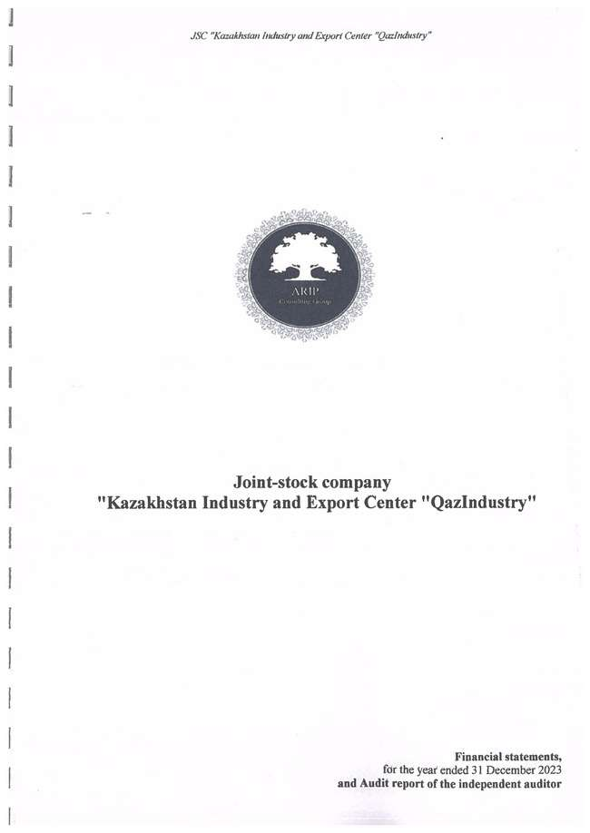

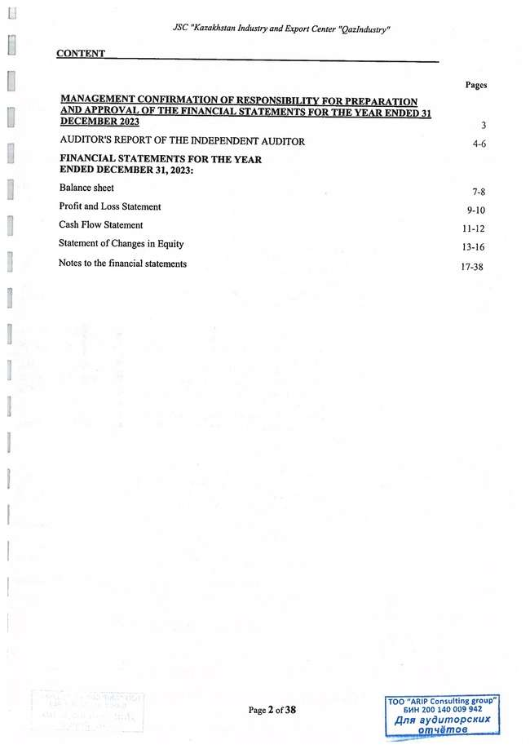

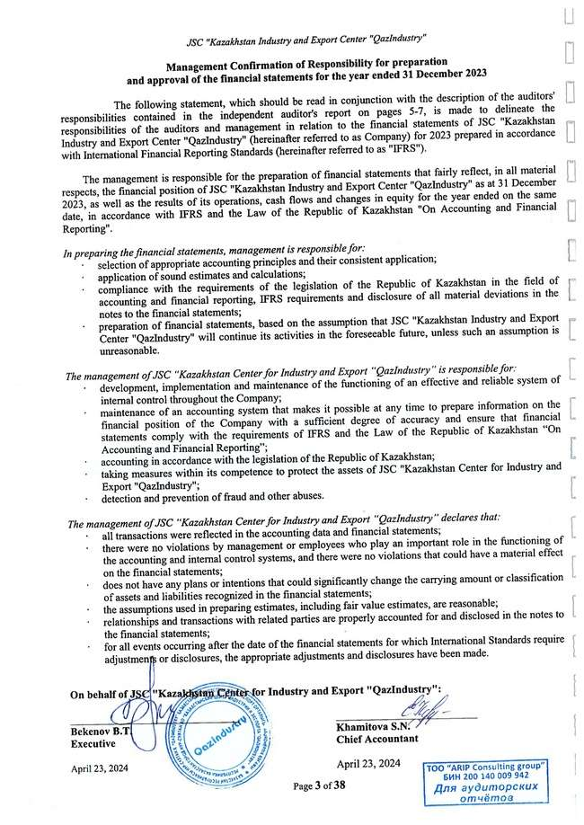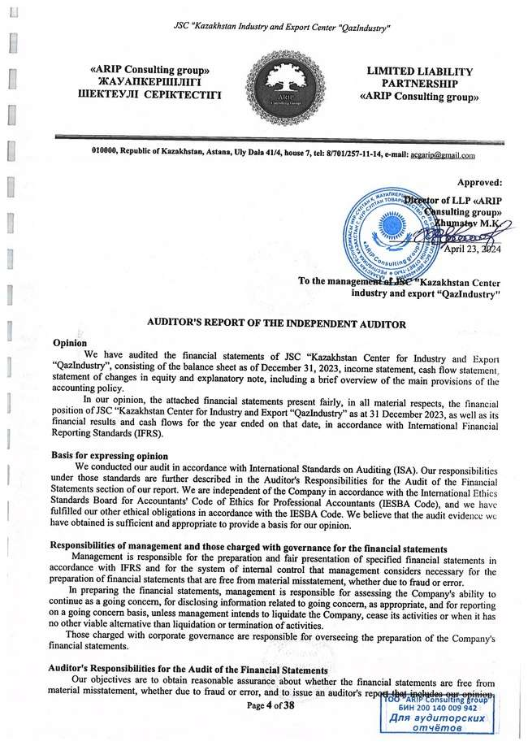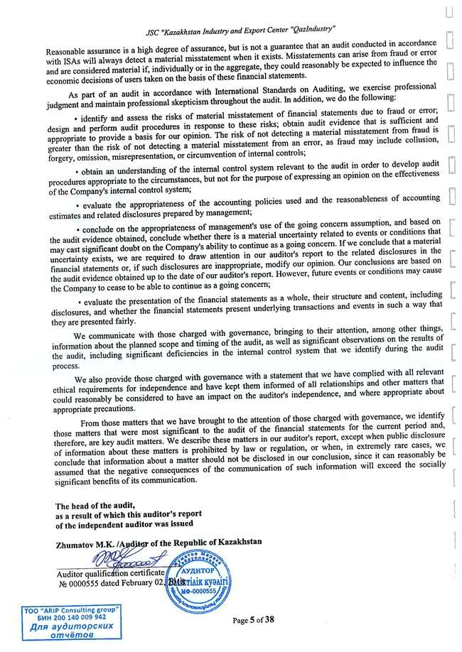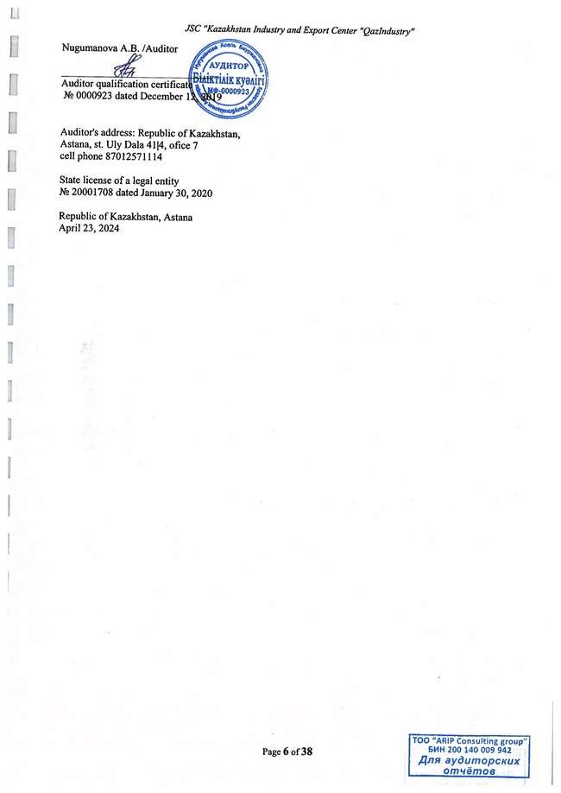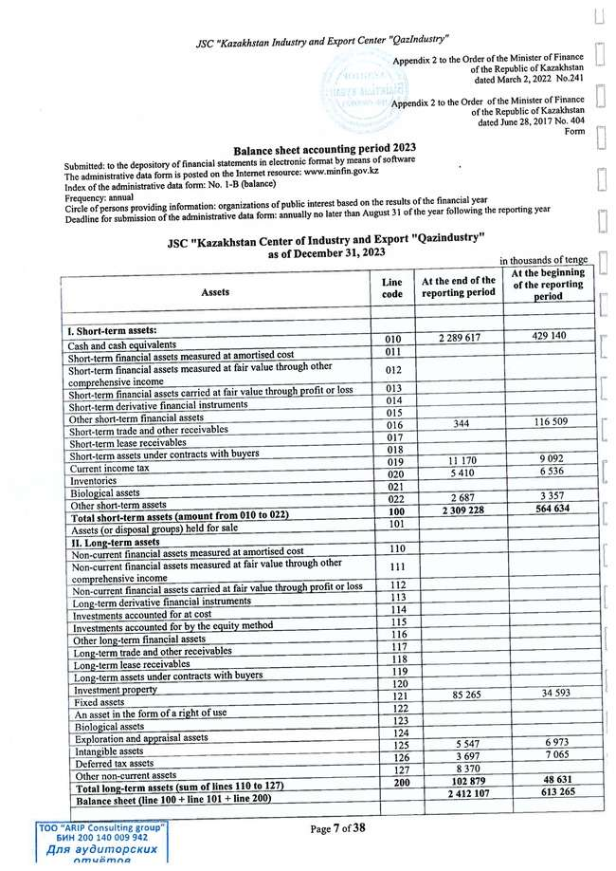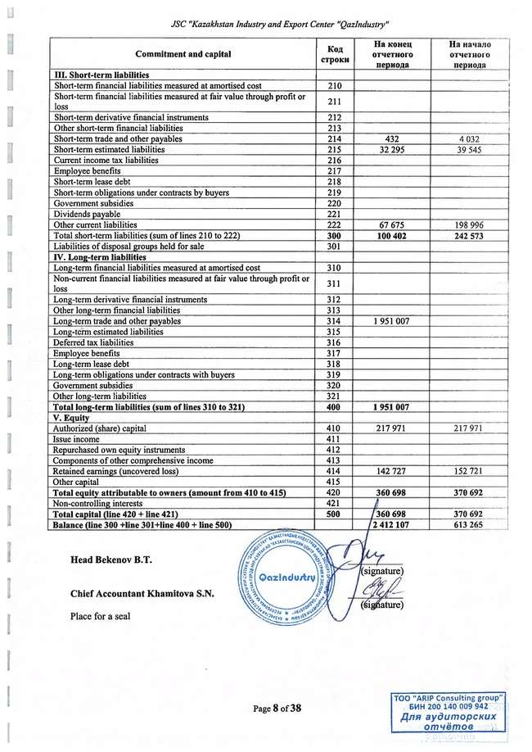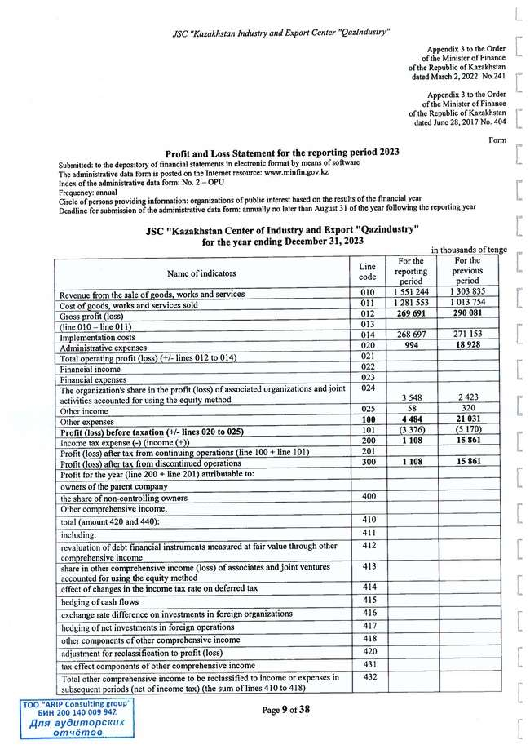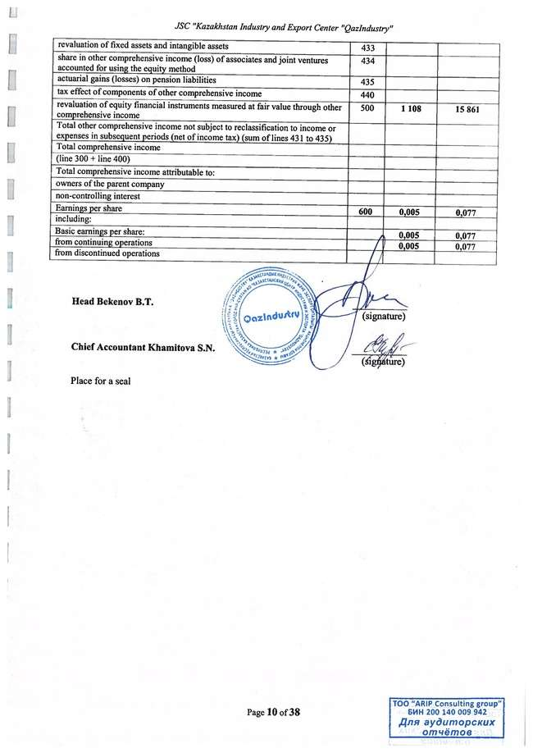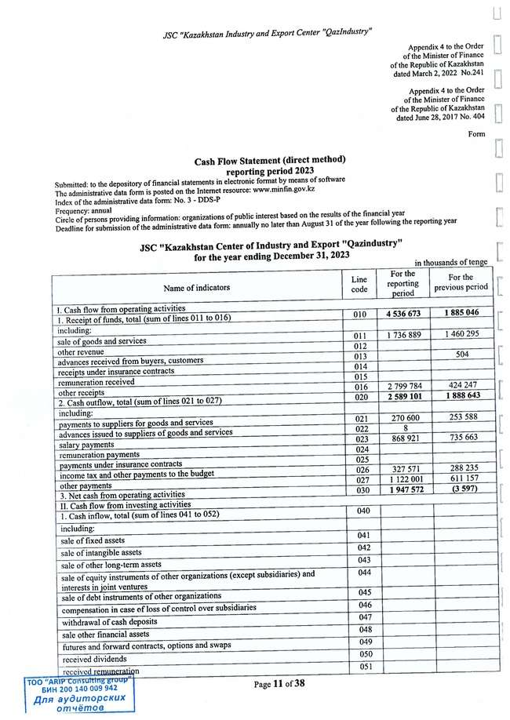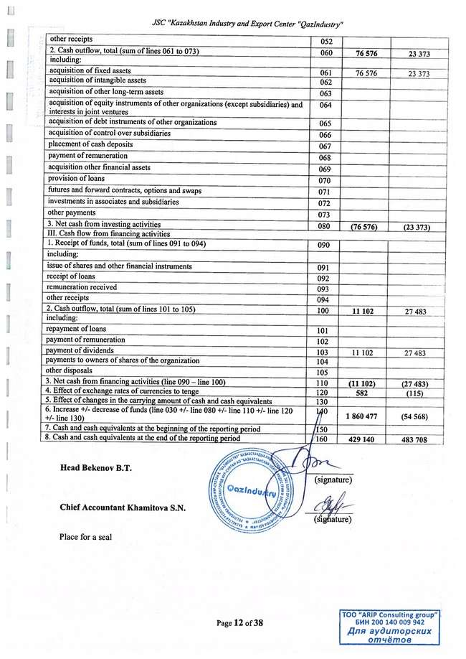

1. *Harmonized with the Law of the Republic of Kazakhstan "On Industrial Policy" and the National Project "Sustainable Economic Growth aimed at improving the welfare of Kazakhstanis*" *approved in 2021*